Dry eyes
NEA

Table of Contents
2 Analysis 5
2.1 Introduction 5
2.2 Problem statement 6
2.3 Research 6
2.4 Analysis Outcome 8
2.4.1 Eyeblink 8
2.4.2 Blink Well 10
2.5 End user 11
2.6 End user questionnaire 11
2.7 Solution 12
2.8 Objectives 13
2.9 Completed application 14
3 Design 14
3.1 System Architecture 14
3.2 Front-end application 15
3.2.1 UX Design 15
3.3 Back-end application 16
3.3.1 System flow chart 17
3.3.2 Blink detection 18
3.3.2.1 Class diagram 18
3.3.2.2 Flow chart blinks 20
3.3.3 Logistic regression 22
3.3.3.1 Data types of variable definition 24
3.3.3.2 Flow chart 25
3.3.4 Database Design 26
3.3.4.1 ER diagram 26
3.3.4.2 Database Tables 27
3.3.4.3 Potential database queries: 28
3.3.5 UML state transition diagram 29
3.3.6 Algorithms 30
3.4 Backend and Frontend flow 30
3.4.1 Create a new user 30
3.4.2 Already a user 30
3.4.3 Blink detection and breaks 31
3.4.4 Set Setting 32
3.4.5 Statistics 32
3.4.6 Testing strategy 32
4 Technical solution 33
4.1 File structure 33
4.2 Front end 34
4.2.1 App.js 34
4.2.2 Pages folder 34
4.2.2.1 Home page (“/”) 35
4.2.2.2 Profile page(“/profile”) 36
4.2.2.3 Blink page(“blink”) 40
4.2.2.4 Settings page (“/settings”) 41
4.2.2.5 Stats page (“stats”) 44
4.2.2.6 Camera context 47
4.2.2.7 Custom nav 52
4.2.3 Context folder 52
4.2.3.1 Context data 52
4.3 Backend code 53
4.3.1 Flask app 53
4.3.1.1 Main.py 53
4.3.1.2 Models.py and config.py 58
4.3.2 Blink detection class 59
4.3.3 Logistic regression model 63
5 Testing 66
5.1 API testing 66
5.2 Testing whole system 67
5.2.1.1 Fixes to fails 69
5.2.1.2 Reason why can’t fix the others 70
6 Instructions to run the program 70
7 Evaluation 71
8 References 72
9 Abbreviations 73

Images:
Image 1: IBI of normal person and a person with dry eyes 7
Image 2:logistic model of whether someone has dry eyes or not depending on mean log IBI 8
Image 3: eyeblink settings page 9
Image 4: eyeblink eye training settings 9
Image 5: eyeblink reminder to blink 9
Image 6: eyeblink break timer 10
Image 7: blinkwell settings page 10
Image 8: blinkwell reminder to blink 10
Image 9:UX design 15
Image 10:UX design 15
Image 11: class diagram 17
Image 12:EAR landmarks 18
Image 13:EAR equation 18
Image 14: linear function logistic regression 21
Image 15: sigmoid function logistic regression 21
Image 16: loss function logistic regression 21
Image 17: gradient decent logistic regression Andrew Ng 22
Image 18: gradient decent formula logistic regression 22
Image 19:ER diagram 25
Image 20: data flow creating a new user 29
Image 21: data flow already a user 30
Image 22:data flow blink detections and breaks 30
Image 23: data flow set settings 31
Image 24: data flow showing statistics 31
Image 25: file structure 32
Image 26: home page 34
Image 27: log in page 35
Image 28: profile page 38
Image 29: blink page 39
Image 30: blink page 39
Image 31: settings page 42
Image 32: stats page 44
Image 33: break alert 49
Image 34: csv file training and test data 63
Image 35: excel result table 64

Code:
Code 1:App.js 30
Code 2:Home page 31
Code 3: profile page 1 32
Code 4: profile page 2 33
Code 5: profile page 3 34
Code 6: blink page 1 35
Code 7: blink page 2 36
Code 8: settings page 1 37
Code 9: settings page 2 38
Code 10: settings page 3 38
Code 11: settings page 4 39
Code 12: stats page 1 40
Code 13: stats page 41
Code 14: video recording, Break 1 42
Code 15: video recording, Break 2 43
Code 16: video recording, Break 3 44
Code 17: video recording, Break 4 45
Code 18: video recording, Break 5 46
Code 19: nav bar 46
Code 20: context data 47
Code 21: API's 1 48
Code 22: API's 2 49
Code 23: API's 3 50
Code 24:API's 4 51
Code 25: API's 5 52
Code 26: flask app configuration 52
Code 27: defining database 53
Code 28: blink detection and IBI calculation 1 54
Code 29:blink detection and IBI calculation 2 55
Code 30:blink detection and IBI calculation 3 56
Code 31: logistic regression 1 57
Code 32: logistic regression 2 58

Table:
Table 1: dry eye poll 11
Table 2: dry eyes method poll 12
Table 3: find it hard to follow poll 12
Table 4: what challenge poll 12
Table 5: used a software application poll 12
Table 6: why did not use software poll 12
Table 7: data types of logistic regression 23
Table 8: user database design 26
Table 9: blink database design 26
Table 10: settings database design 27
Table 11: algorithms 29
Table 12: Api testing 64
Table 13: system testing 67
Table 14: fixes to fails 68
Table 15: reasons of not fixed 68
Table 16: abbreviations 70

flowcharts:
Flowchart 1:system architecture 12
Flowchart 2: overall system flow 14
Flowchart 3: overall IBI calculation flow 17
Flowchart 4: Blink calculation and IBI calculation flow 18
Flowchart 5: logistic regression 1 22
Flowchart 6: logistic regression 2 23
Flowchart 7: UML state transition 26

Analysis

Introduction
In a world filled with screens, the issue of dry eyes has become a major health concern, especially with the constant use of digital devices. The problem of dry eyes usually gets worse by long periods of time spent on phones, computers and tablets for work, education, and entertainment. This issue is increasingly affecting people, particularly teenagers and young adults (details can be seen her (Cleveland Clinic, n.d.)e).

Dry eyes is usually caused by low blink rate of eye lids or insufficient tear production or poor tear quality, leading to discomfort and blurry vision and can also lead to a more severe problems if not addressed in time.

My analysis mainly focuses on the specific cause that is low blink rate during the exposer to digital screens. Low blink rate usually exposes eyes to air longer, leading to higher rate of evaporation of the tears, making eyes drier.

The reason of choosing this topic is based on my personal experience of dry eyes. Over the past year, both during and after my GCSE exams, I had experienced a significant escalation in the severity of my dry eyes, greatly complicating my daily life. Despite numerous visits to various specialists, the relief I tried to find remained unknown. Despite diligently following medical advice for a year, the improvement was minimal; I merely grew accustomed to the discomfort without experiencing any substantial relief. The doctors recommended two methods: 1) artificial tears, which provided momentary relief, and 2) the most recommended and least invasive method: 20-20-20 rule (taking a 20-second break to look at something 20 meters away every 20 minutes of screen time).

However, the second method proved challenging to follow in my daily routine as when I am focused on schoolwork or entertainment, it is hard, annoying and tedious to keep track of time, and thus making it hard to follow diligently, failing to achieve the expected results.

To address the challenge of adhering to the 20-20-20 rule and especially during the work on digital screen, I started thinking about the possible solutions and as a result, I came up with an idea of making an application that can be installed in on computer and remind the user working on the digital screen to take a break if eye blink rate is lower than normal.

Exploring on the possible application, I found that while many software applications are there to allow the user to set reminders to take break, it does not support the scenario of prevention and does not have the intelligence of whether break is even needed based on eye blink rate.

Problem statement
As stated in the previous section that my analysis is mainly focused on 20-20-20 rule solution for dry eye caused due to low eye blink rate.

The reason I specifically choose the 20-20-20 rule is due to its non-invasive, long-term effect and cheapest option out of all options to treat dry eyes or at least to ease the problem.

Further explaining, the problem of the 20-20-20 rule, highly recommended, is to follow diligently. The main reason the 20-20-20 rule showed significant success in medical research but failed to work effectively for the general population is due to the use of specialized software and the supervision of other people in studies (details here and here).These programs alert users to take breaks, whereas common users must rely on their own willpower and memory to take breaks continuously. These software applications also measure blink rate of user and test individual in real time reminding them to take breaks and blink when a decrease in blink rate is detected by the software.

Another issue with the 20-20-20 rule is that although it was designed for easy integration by anyone without the need for special equipment, it does not consider the fact that a person's blink rate fluctuates throughout the day. This means that even if someone blinks normally during the first 20 minutes, they are still required to take a break according to the rule. These unnecessary breaks can lead to distractions, as breaks are only necessary when a person's blink rate is insufficient, and they need to rejuvenate the moisture in their eyes

Research
My primary source of information was from the national library of medicine where medical research documentations can be found. Below is a summary of the information I got from my research.

Article over internet gave me more thorough Insite on dry eyes (details can be seen here) such as what it is, how it is caused and how it might be treated etc. To summarise what I read from the article: Dry eyes result from an unstable tear film (tears not covering they eye properly and consistently) due to reduced tear production or poor tear quality, leading to symptoms like stinging, burning, or a gritty sensation in the eyes. Factors such as skin conditions, eye surgery, prolonged digital device use, and environmental habits like smoking or allergies commonly contribute to this condition.

Treatment options include modifying the environment by reducing airflow and screen time, using humidifiers, and practicing good eye hygiene. Topical lubricants, and in some cases, surgery, are also utilized to manage dry eyes (detail can be seen here)

Research highlights that more time spent using digital devices increases the likelihood of dry eyes (details can be seen here). This is because prolonged screen exposure can lead to poorer tear quality (due to blue light) and insufficient blinking (as when people are focused on some tasks they tend to blink less), both of which are essential for keeping the eyes moist and preventing dryness.

Figure 1 shows how IBI (inter blink interval or time duration between consecutive blinks) of individuals with dry eyes compare with individuals who do not, which are different for people with dry eyes and people that do not, which further shows how a person with dry eyes blinks significantly less than a person without dry eyes (details shown here). I plan to use the logistic model in figure 2 to help me intelligently deduce if a person’s blink rate is that of a normal person or not. I decided not to take the average blink rate (5.6 per min) as it is an average and therefore not that accurate, defeating the whole point of my program.

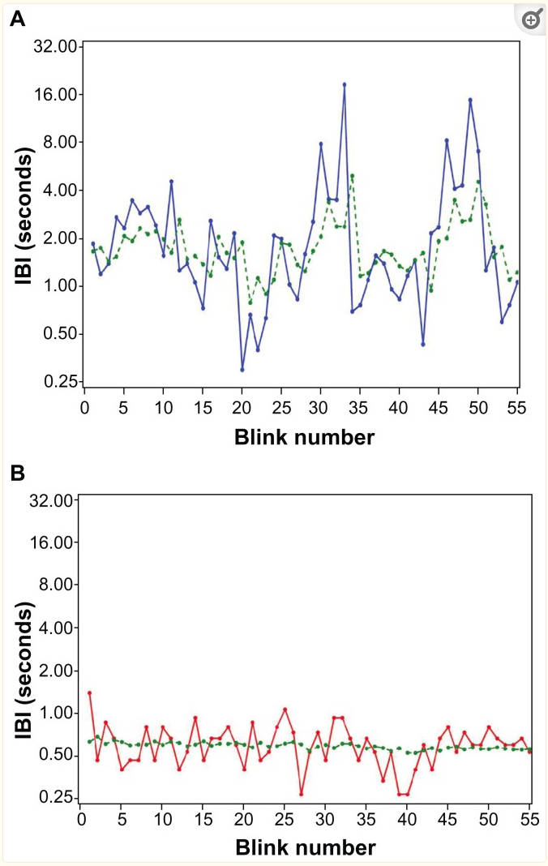
Image 1: IBI of normal person and a person with dry eyes
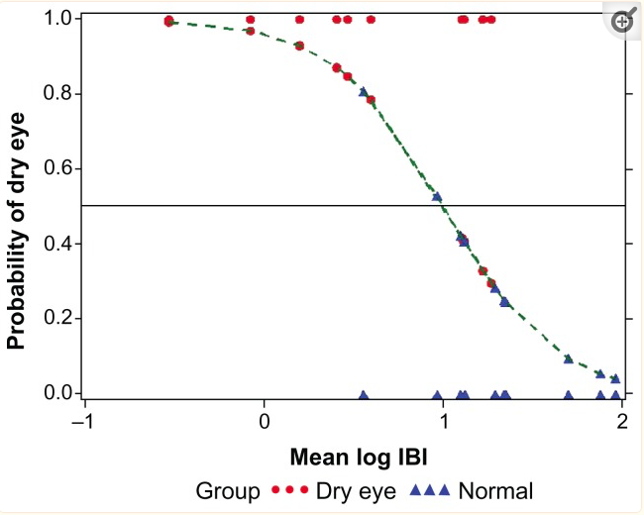
Image 2:logistic model of whether someone has dry eyes or not depending on mean log IBI

Analysis Outcome
There are two current software applications available to normal users one called Eyeblink and the other called Blink Well. Both software applications are tools to monitor your blinking patterns via accessing your webcam feed and prompting regular breaks. Below is a summary of what they provide.

Eyeblink
Eyeblink (details shown here) measures your blink rate every half an hour and provides you with statistics. It calculates your eye health based on these measurements and displays them on a graph. While ordinary cameras can't detect blink completeness, blink training (performing complete blinks) which is important because only when the eyelids touch, the third layer of the tear film, the lipid layer, is renewed which protects the eye from tear evaporation which is still beneficial even if your blink rate is sufficient.

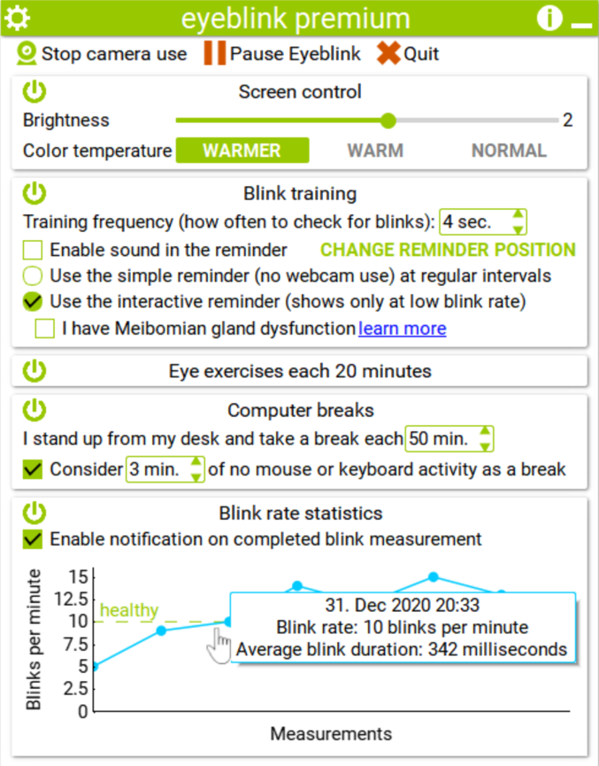
Image 3: eyeblink settings page

Eyeblink offers two types of reminders: a simple reminder that appears at regular intervals, and an interactive reminder that appears only when your blink rate is low. The interactive reminder disappears once you blink.

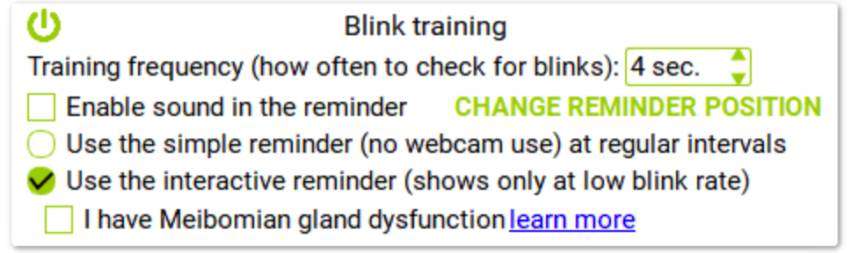
Image 4: eyeblink eye training settings

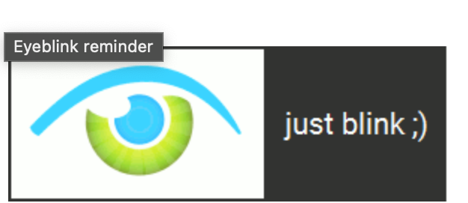
Image 5: eyeblink reminder to blink

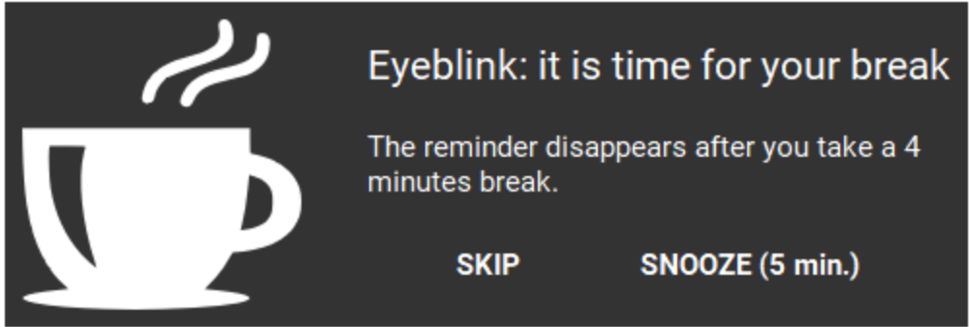
Image 6: eyeblink break timer

It's designed to minimize interruption, appearing as a small window in the screen corner. Eyeblink operates in the background and can be controlled through your blinks.

Blink Well
A similar software with slightly less features was also found (further details shown here). Using just a computer-connected webcam, Blink Well employs a blink detection algorithm to track the user's blink rate and screen usage. This data is used to send reminders to blink and take breaks.

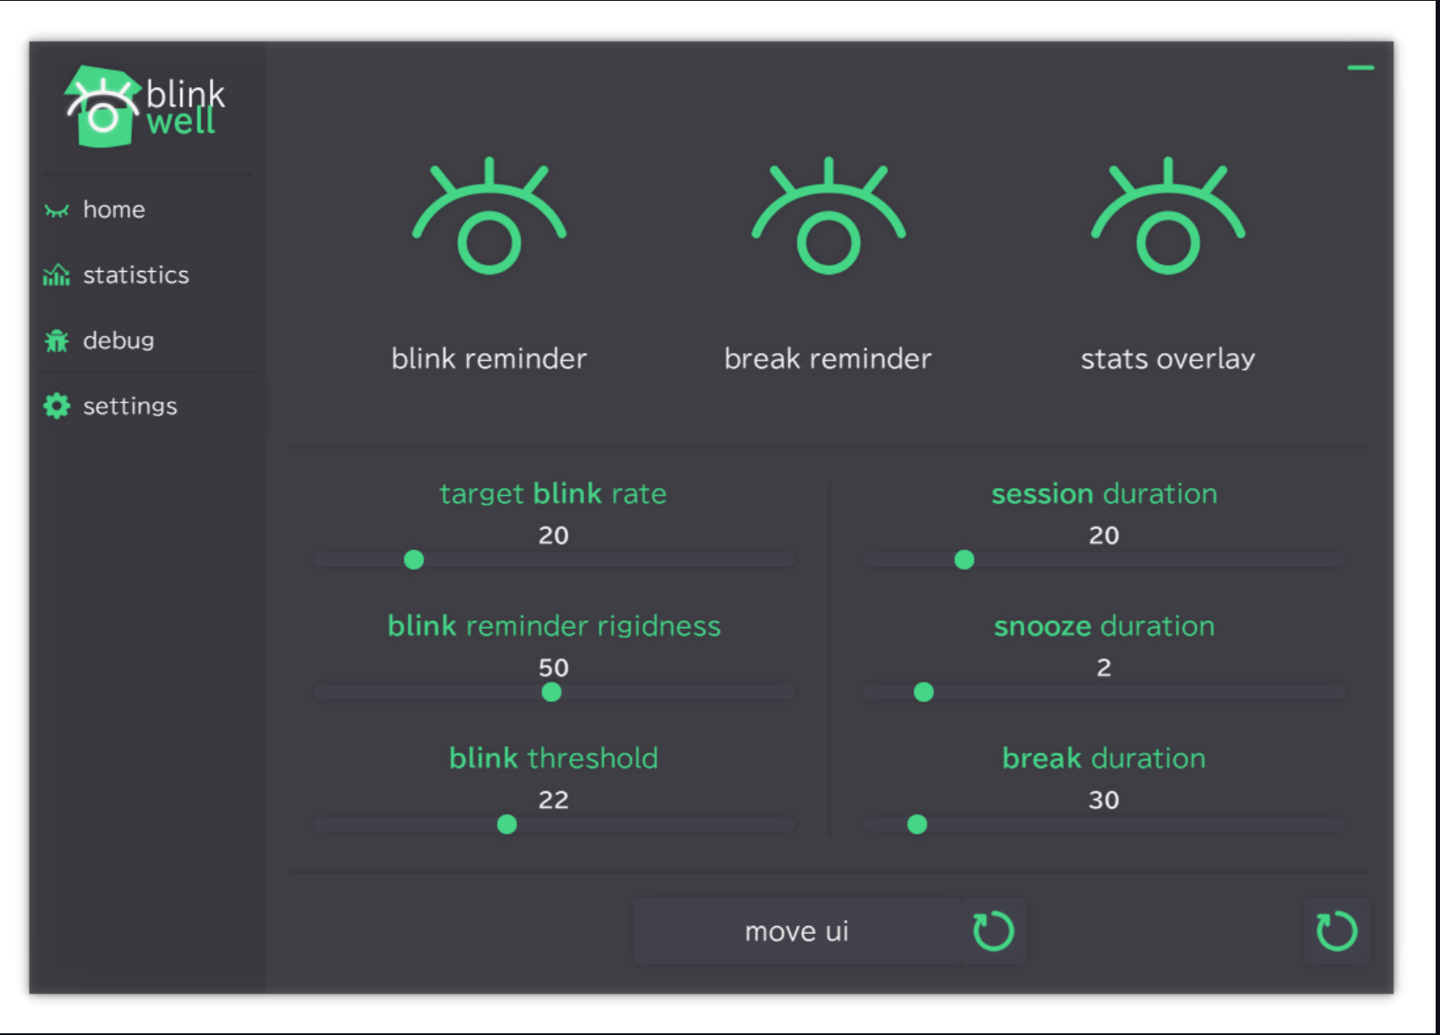
Image 7: blinkwell settings page

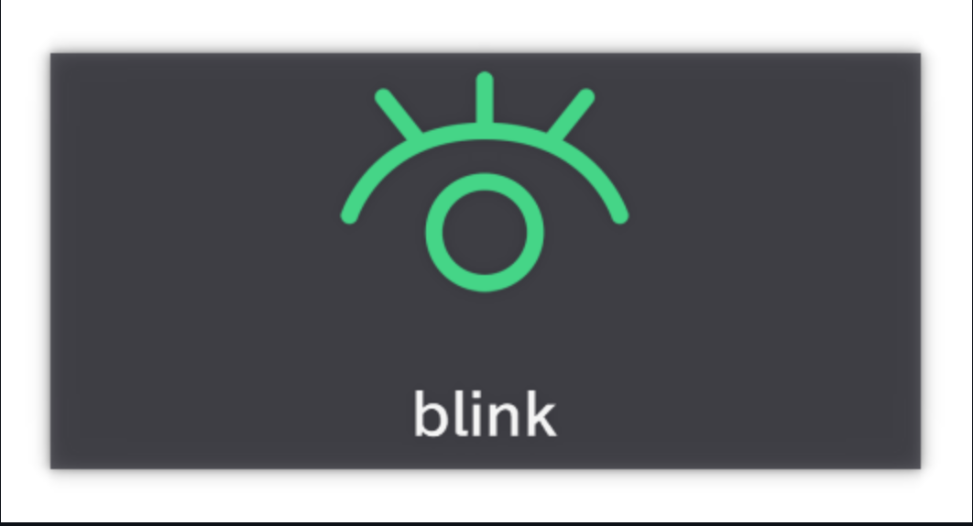
Image 8: blinkwell reminder to blink

Both systems perform the task that I envision my software to do however a big downside to both are that they are not compatible to mac. I plan to make a mac version of the software with slightly different implementation regarding the breaks. The other systems give a reminder to blink and once they blink the reminder disappears, while for my system I will only prompt a break if blink rate is low consistently for a set duration of time.

End user
This section describes the end users for the target software application under the NEA project.

The obvious users are the ones who suffer with dry eyes that is persistent. But more specifically people who uses computers for work or for education will be most benefited from this software. But people who do not have dry eyes and want to prevent dry eyes will also find the application beneficial to use on their computers.

After discussion with few end users, it became clear that a software like this is needed. My father who has been suffering from dry eyes for few years, has tried my solutions. Doctors said the only solution is to decrease the amount of time spent in front of a screen however this proved very hard as my dad’s work heavily relied on the use of a computer. After asking and questioning him about the significance this software will have on his daily life, he said it would be an excellent piece of software to help with this problem.

The same consultation was done with some other friends of mine who are also suffering from dry eyes and all of them had the same thoughts of how this software would really help them.

End user questionnaire
Below is a summary of a questionnaire that I emailed to some of my friends and family.

Question: Do you have dry eyes?
Results:
Options | Response
Yes | 64%
No | 13%
Maybe | 23%
Table 1: dry eye poll
Question: What methods do you use to help with your dry eye?
Results:
Options | Response
20 -20-20 rule | 35%
Artificial tears | 48%
humidifier | 4%
surgery | 1%
others | 0%
None | 12%
Table 2: dry eyes method poll
Question: If you use the 20 -20-20 rule, do you find it difficult to follow the rule?
Results:
Option | Response
yes | 81%
no | 19%
Table 3: find it hard to follow poll
Question: What challenges do you find in adhering to the 20-20-20 rule?
Results:
Options | Response
Hard to keep consistent | 54%
Hard to remember | 14%
Hard to stop task every 20 min | 22%
No challenge | 10%
Table 4: what challenge poll
Question: Have you used any of the software to help you follow this rule?
Results:
Option | Response
yes | 34%
no | 66%
Table 5: used a software application poll
Question: If not, why did you not use it?
Results:
Options | Response
Did not know such software existed | 53%
Can’t use it as not supported on my computer | 41%
Did not work | 1%
others | 5%
Table 6: why did not use software poll

Solution
After analysing the questionnaire results, it became clear that a significant majority of respondents experience dry eyes, indicating a strong need for this type of software. Additionally, many people find it challenging to consistently follow the 20-20-20 rule. Therefore, I believe my solution will address most of the issues faced by individuals trying to implement this rule. While my approach will significantly simplify the 20-20-20 rule, it will retain its core principle; taking breaks to rest the eyes and ensure proper eye moisturization.
The software, I propose, aims to simplify the 20-20-20 rule application into a more practical and user-friendly system. By creating an environment like controlled experiments conducted by specialists, it will make adhering to the rule more beneficial and effortless. Instead of rigidly scheduling breaks, the software will intelligently prompt users only when their blink rate falls below a certain threshold over a defined period, ensuring breaks are taken only when necessary.
Upon prompting, the software will automatically initiate a 20-second timer and notify the user when the break is complete. This approach minimizes user effort, making it easier to follow consistently and yielding better results than other methods.

Objectives
The goals of the project are listed below:
- Users log in and sign in
- Decide blink rate is normal:
Software will monitor user’s eye blink rate as defined in the design document.
  - Software must be able to store IBI of blink
  - Software must store average IBI over the 20 min in a database
  - Software must be able to predict if average IBI is normal or not
  - Result must be able to store in a database
- Notification of a timer shown to user if blink rate is not normal
- 20 sec timer notification will automatically be started
- Alert sent to user that timer is finished
- User settings
- Change break timer
- Change interval at which blink rate is compared
- History of blink rate
- Graph to show blink rate for the day

Completed application
My completed project will be a website which the user can interact with. The user will be able to make a personal account where they can customise settings, see statistics and start and stop the timer.

Design

This section explains the solution design to solve the dry eyes problem for computer users.

To address dry eyes problem, I created the app that runs in the computer to detect users eye blink rate and notifies the users to take break if the blinking rate in lower than the recommended threshold.

Blink app is comprised of frontend and backend application which communicates over APIs. Backend application also connect with a flask-based alchemy SQL database.

The application is detailed out in the following sections.

System Architecture

Below diagram depicts the architecture if the solution developed for dry eyes.

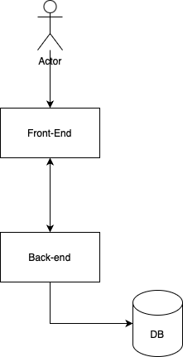
Flowchart 1:system architecture

Front-end application
Front end shall be developed in React.js. React is strong framework to develop a front-end for users. It is a JavaScript library that is built by Meta.
Besides react, Material user interface (MUI) shall be used to create the user interface components to decrease the development time because MUI (Material UI) provides built in React components for the ready-made use. MUI is supported by a large community, making it a rich source of user interface components.

UX Design
Below is how I envision my front end to look like and the number of pages I would like to have.
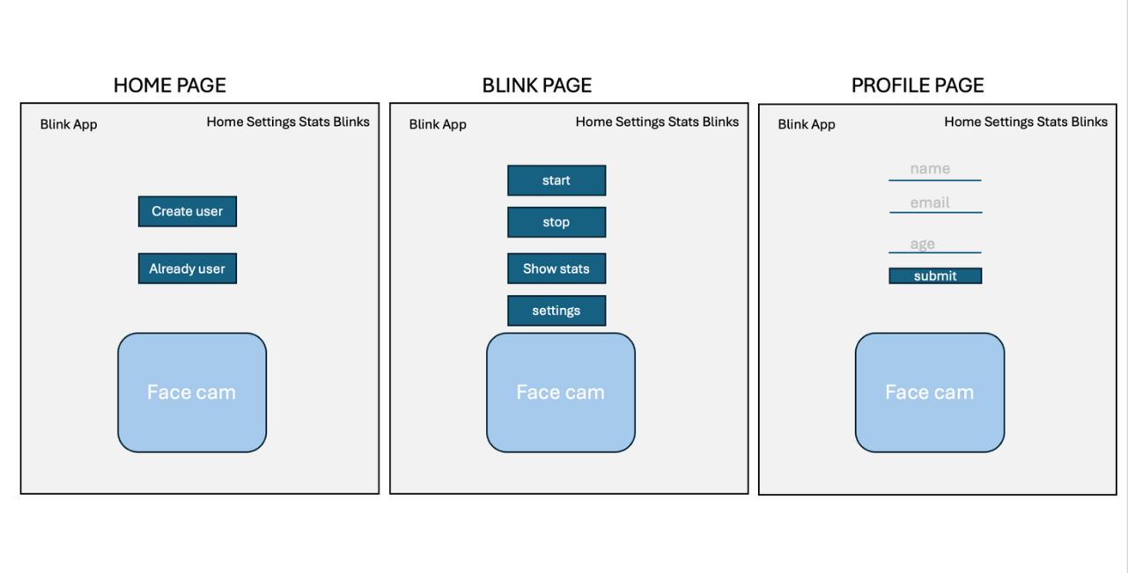
Image 9:UX design
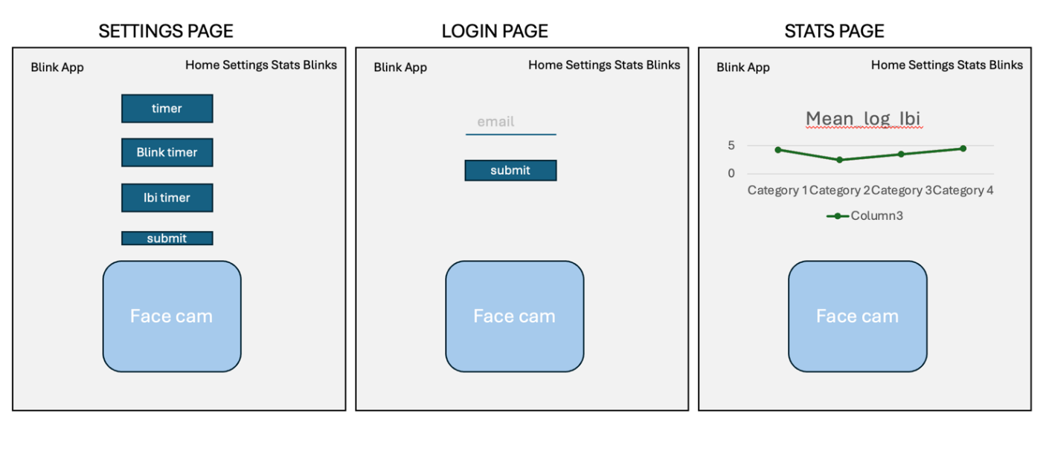
Image 10:UX design

Back-end application
Backend will be developed in flask. Flask is a micro framework written in python. In this I created my APIs and database in flask SQL Alchemy which is an extension of flask that allows you to use SQL alchemy alongside flask. I used flask as my backend framework as all my other logics such as blink detection and normal IBI logistic model, will be made in python for simplicity as there are many modules which make these functions easy to implement and python is a language I am comfortable in using.

System flow chart
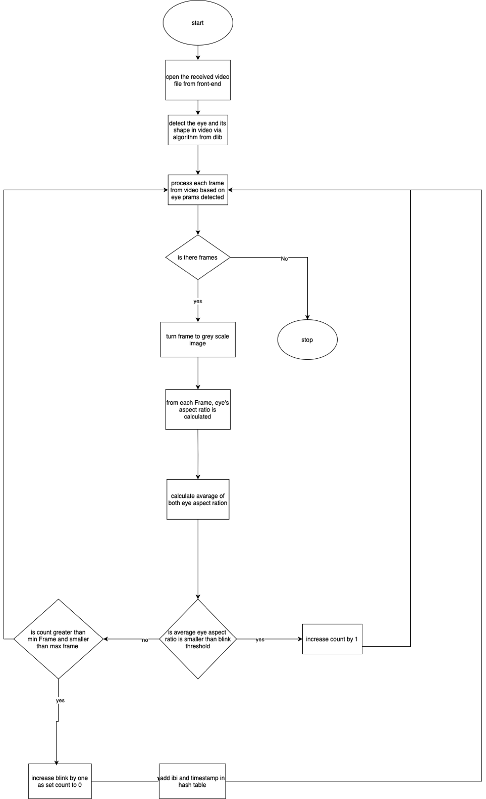
Flowchart 2: overall system flow

Blink detection

Class diagram

Below is a class diagram from my two classes.
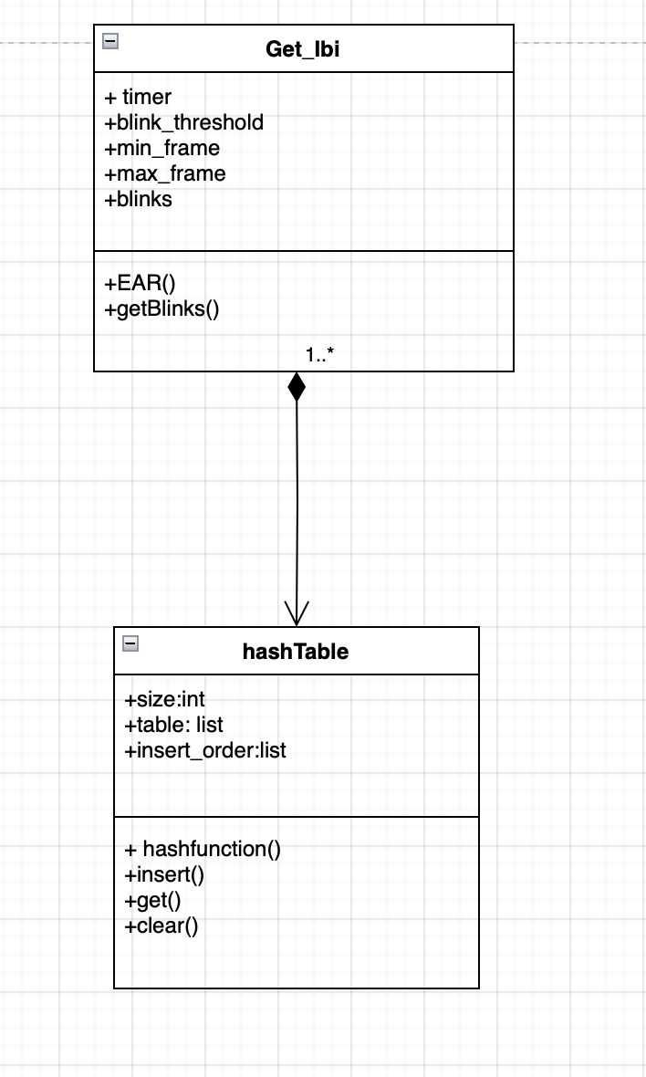
Image 11: class diagram

The blink detection will be defined in a class as it will make using it in my backend application easier via classes abstraction and encapsulation features (details can be seen here).

I will be using CV2 and dlib as modules for blink detection. CV2 is the main module in OpenCV that allows me to work with videos. Dlib is a toolkit for machine learning which is used for computer vision and image processing. Dlib is the module that will detect the eyes allowing us to do some computation to detect if the user has blinked or not. The dlib module will allow us to extract key facial landmarks specifically on the eye.
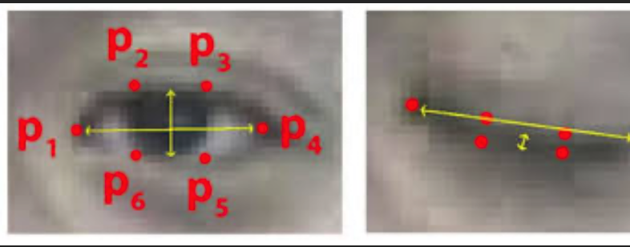
Image 12:EAR landmarks

There are 6 key landmarks on each eye. After extracting them via dlib, we can find the EAR (eye aspect ratio) to determine how open the eye is. It is computed from the Euclidian vertical (sum of p2 subtracted by p6 and p3 subtracted by p5) and horizontal distance (p1 subtracted by p4) which calculates the distance between the
top lid and lower lid.
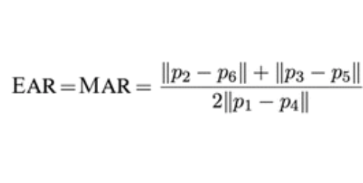
Image 13:EAR equation
When the EAR falls below a certain threshold (for example 0.5) the function will class it as a blink.

Alongside the blink detection, this class also calculates and stores the IBI (inter blink interval), or the time difference between each consecutive blink, in a hash table. I decided to use a hash table as it will be easier to retrieve timestamps of previous blinks to calculate the IBI of the current blink. The IBI is just calculated by the difference between the time the previous blink was detected and the time of the current blink detected. The flow chart below illustrates how this class should work.

Flow chart blinks
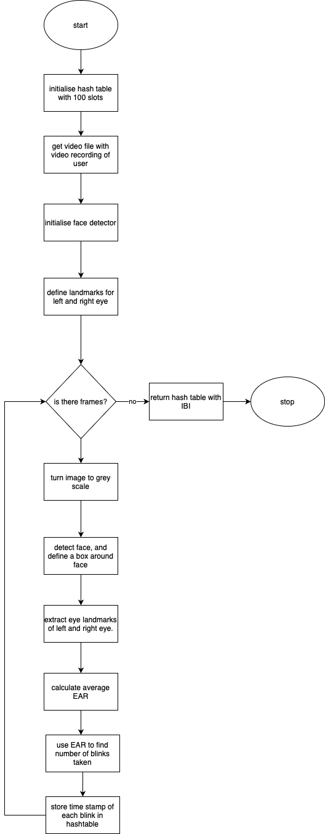
Flowchart 3: overall IBI calculation flow

Below is the flow of how a blink is detected and how the IBI is calculated. If the average EAR falls below the given threshold of a set amounts of frames it is considered a blink. When a blink is detected its IBI is calculated by comparing it with the previous one.

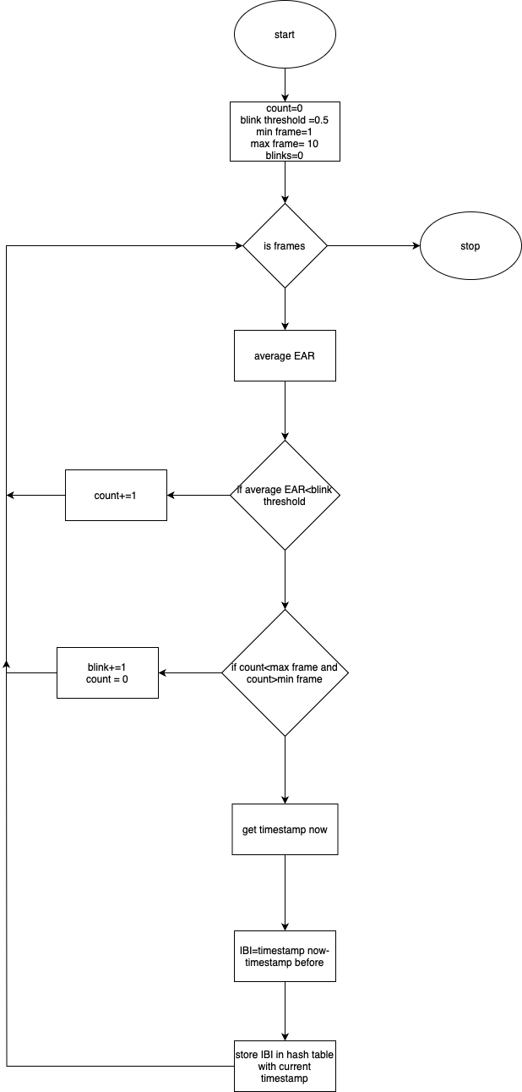
Flowchart 4: Blink calculation and IBI calculation flow

Logistic regression
Logistic regression is a supervised machine learning algorithm that returns a 0 or 1 by predicting the probability of certain event happening (details here). For my case it predicts the probability a person’s mean log IBI being of a normal person.

From figure 2, I extracted some of the data of a normal person and used it as my training data for my logistic regression model.

I decided to make the logistic regression algorithm from scratch.

The following details on logistic regression were taken from the machine learning course from Coursera taught by Andrew Ng and the link here.

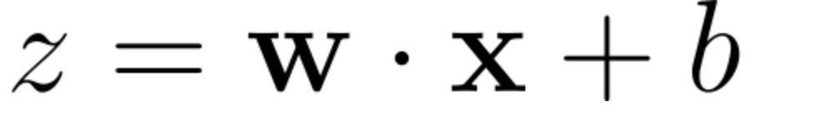
Image 14: linear function logistic regression

The purpose is to find an equation in the form shown above that fits the data the best i.e. “line of best fit”. Where X is the input, Z is the output and w is the weight and b is the bias. They all are represented as vectors. The equation above need not to be linear.

The equation above is put into a sigmoid function to map x values to probabilities. It transforms the results to a value between 0 and 1.
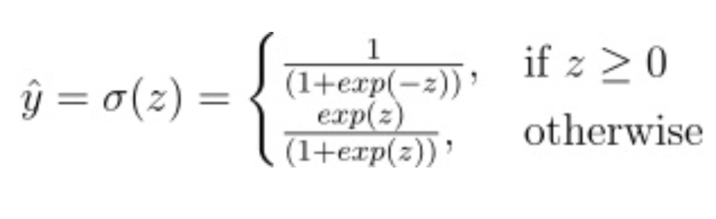
Image 15: sigmoid function logistic regression

To find this “line of best fit” we must minimise the following function called the binary cross entropy loss function:
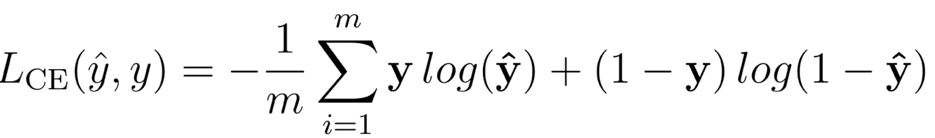
Image 16: loss function logistic regression

This function tells the algorithm how close the prediction is to the actual value. The closer it is the smaller the loss.

To find the minimum loss we use another function called gradient decent. All it does is it finds the gradient of the loss function with respect to the weight w and a separate gradient of the loss function with respect to the bias b. Using the gradients, the weights and biases are updated. This can also be thought of as the direction to take to find the minimum loss (minimum turning point).
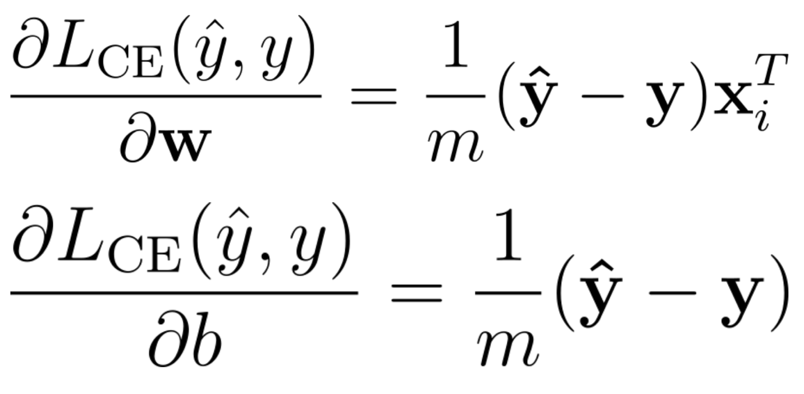
Image 18: gradient decent formula logistic regression

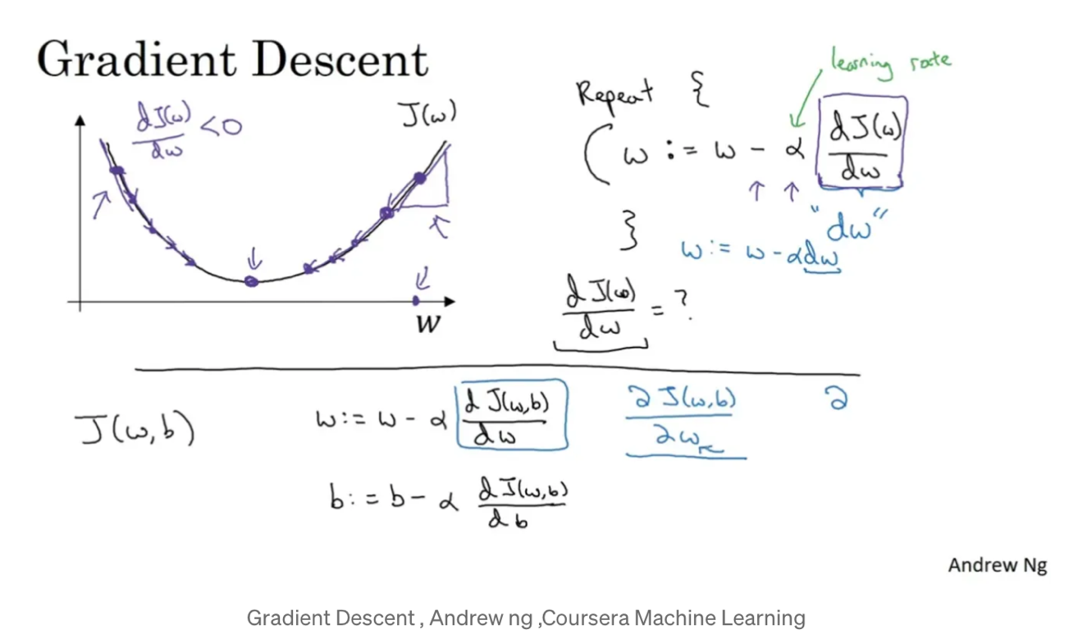
Image 17: gradient decent logistic regression Andrew Ng

From this graph above the gradient decent finds which direction would lead to the minimum of this graph and the learning rate is by how much to move down this graph.

Data types of variable definition

variable | scope | Data type | description
self.lr | instance | Float64 | step size during updates
Self.number_i | instance | Int64 | Number of iterations for gradient decent
Self.weight | instance | ndarray | Part of linear equation
Self.bais | instance | Float64 | Part of linear equation
Self.losses | instance | list | loss values for each iteration during training
X | local | ndarray
A | local | ndarray | Transformed predictions using the sigmoid function
z | local | ndarray
y | local | ndarray
dz | local | ndarray | Derivative of the sigmoid function
dw | local | ndarray | Gradient of the loss with respect to the weights
db | local | Float64 | Gradient of the loss with respect to the bias
y_hat | local | ndarray | Predicted values before applying the sigmoid function
Y_prediction | local | ndarray | final predicted probabilities after applying the sigmoid function
data | global | ndarray
Table 7: data types of logistic regression

Flow chart
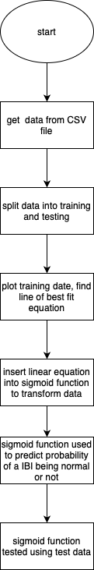
Flowchart 5: logistic regression 1
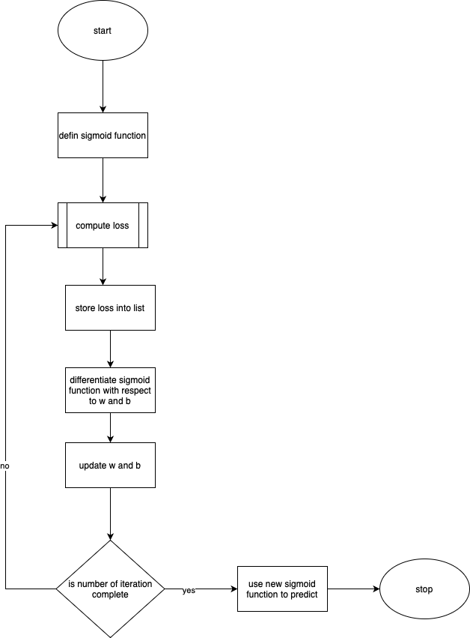
Flowchart 6: logistic regression 2

Database Design

ER diagram
Below is an ER diagram of my database models. One-to-One relationship between settings and users, and a One-to-Many relation between users and
blink.

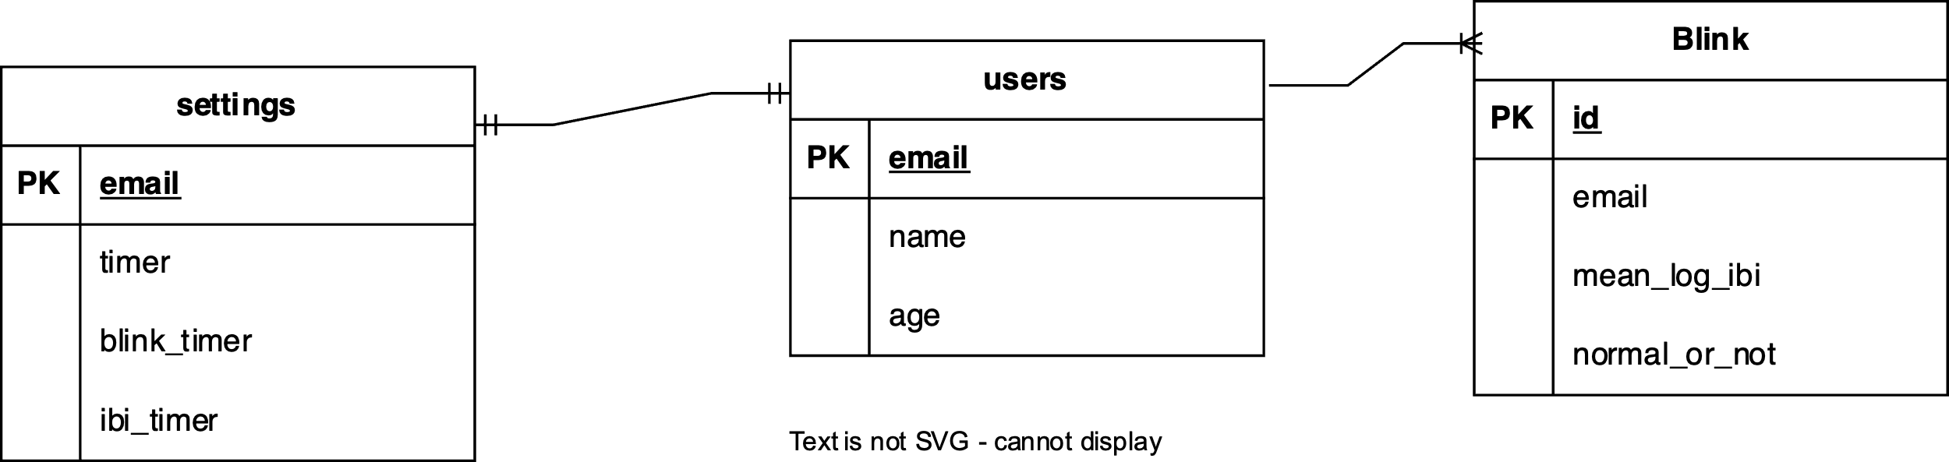
Image 19:ER diagram

Database Tables

Users.db

NAME | TYPE | PURPOSE | EXAMPLE
email | string | Primary key, used to uniquely identify a user | “tanisha@gmail.com”
name | string | Used to show user that this is their account | “Tanisha”
age | integer | Extra information | 17
Table 8: user database design
Blink.db

NAME | TYPE | PURPOSE | EXAMPLE
id | integer | Uniquely identify each entry | 1
email | string | Link each entry to a user | “tanisha@gmail.com”
Mean_log_ibi | integer | The means of the logs of the IBI | 0.98765
Normal_or_not | Integer/Boolean | stores wither normal blink rate or not. 0 is normal and 1 is not normal. | 1
Table 9: blink database design

Settings.db

NAME | TYPE | PURPOSE | EXAMPLE
email | string | To connect the settings to a user. Each user only has one setting. | “tanisha@gmail.com”
timer | integer | The break timer | 20
Blink timer | integer | The duration of time the video is recorded before being sent to backend for finding the number of blinks. | 5
Ibi timer | integer | The number of minutes that needs to go buy before analysing the IBI of the user and storing wither it should start a timer or not | 15
Table 10: settings database design

Potential database queries:

Storing IBI and logistic regression result:
INSERT INTO blink (email, mean_log_ibi, normal_or_not)
VALUES ('user@example.com', 0.1432, 1);

Fetching last 5 results to see if should start a break:

SELECT normal_or_not
FROM Blink
ORDER BY timestamp DESC
LIMIT 5;

Inserting blink data (example values)

INSERT INTO blink (email, mean_ibi, normal_or_not)
VALUES (“tanisha@gmail.com”,1.5, 0)

Settings (example values)

SELECT COUNT(*) FROM settings WHERE email = “tanisha@gmail.com”.
IF (SELECT COUNT(*) FROM settings WHERE email = “tanisha@gmail.com” ;) > 0 THEN
UPDATE settings
SET timer = 30, blink_timer = 600, ibi_timer = 900
WHERE user_id = 1;
ELSE
INSERT INTO settings (email, timer, blink_timer, ibi _timer)
VALUES (1, 20, 300, 1200
END IF;

Adding users (example)

INSERT INTO users (email, name, age)
VALUES ('user@example.com', 'John Doe', 25);

UML state transition diagram

This diagram explains the states during the recordings and breaks.

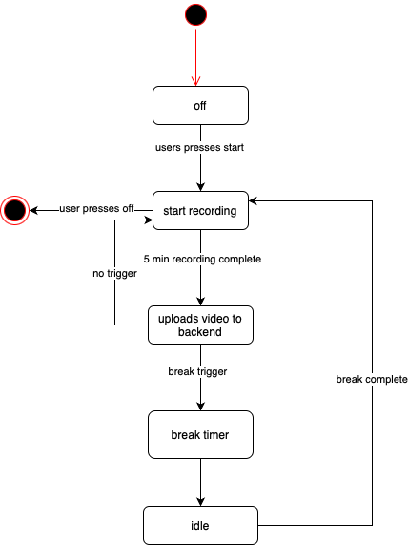
Flowchart 7: UML state transition

Algorithms

Algorithm name | Custom or Third_party | purpose | Time complexity
Blink detection | Custom | To detect all the blink in the video being sent for analysis | O(n)  Time increases as number of frames increases.
IBI calculation | Custom | To calculate the IBI from blinks and then calculate mean of all the IBI’s | O(n)  Time increases as number of frame increases
Logistic regression algorithm | Custom | Classify mean_log_ibi as normal or abnormal | O(nC) where c is a constant
Video uploading and recording | Custom | Records video for set duration, uploads it at regular intervals. | O(n)
Table 11: algorithms

Backend and Frontend flow
Below are sequence diagrams to show the basic flow of data between backend frontend (BlinkApp) and the databases (SettingsDatabase, UserDatabase and BlinkDatabase)

Create a new user
User details from a form is posted to the backend via an API and is stored in the UserDatabase where the email is set as the primary key. If the backend gets the user details a response is sent back to the frontend.

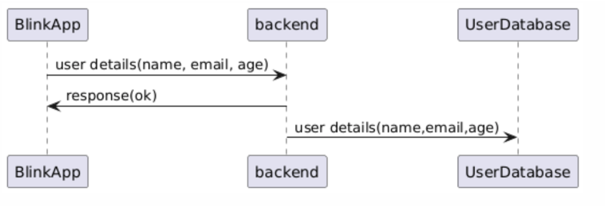
Image 20: data flow creating a new user

Already a user
If the user already has an account, they will be asked for only an email which will be posted to the backend via an API and another API is used to get the name associated with that email which is queried from the UserDatabse beforehand.

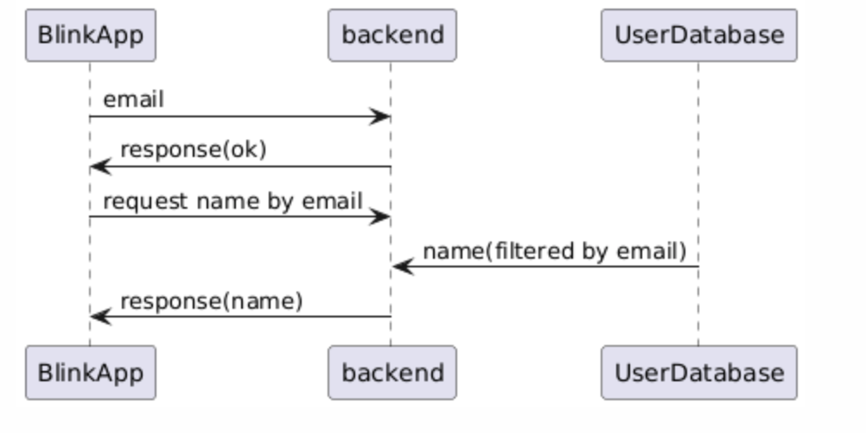
Image 21: data flow already a user

Blink detection and breaks
The settings associated with the email of the user is retrieved from the SettingsDatabase and is used to set timings in the frontend. A video is sent to the backend ever 5 min (or specific time set in settings by user). The backend stores the mean_log_ibi, the email and if the IBI was normal or not which was predicated by a logistic regression model in the BlinkDatabase. The backend retrieves the previous 5 (or specified in settings by user) data that were just added for the specific email and sends a 1 or 0 depending on which one is more frequent. If a 1 is sent a timer will start if not the program will continue the whole process again.

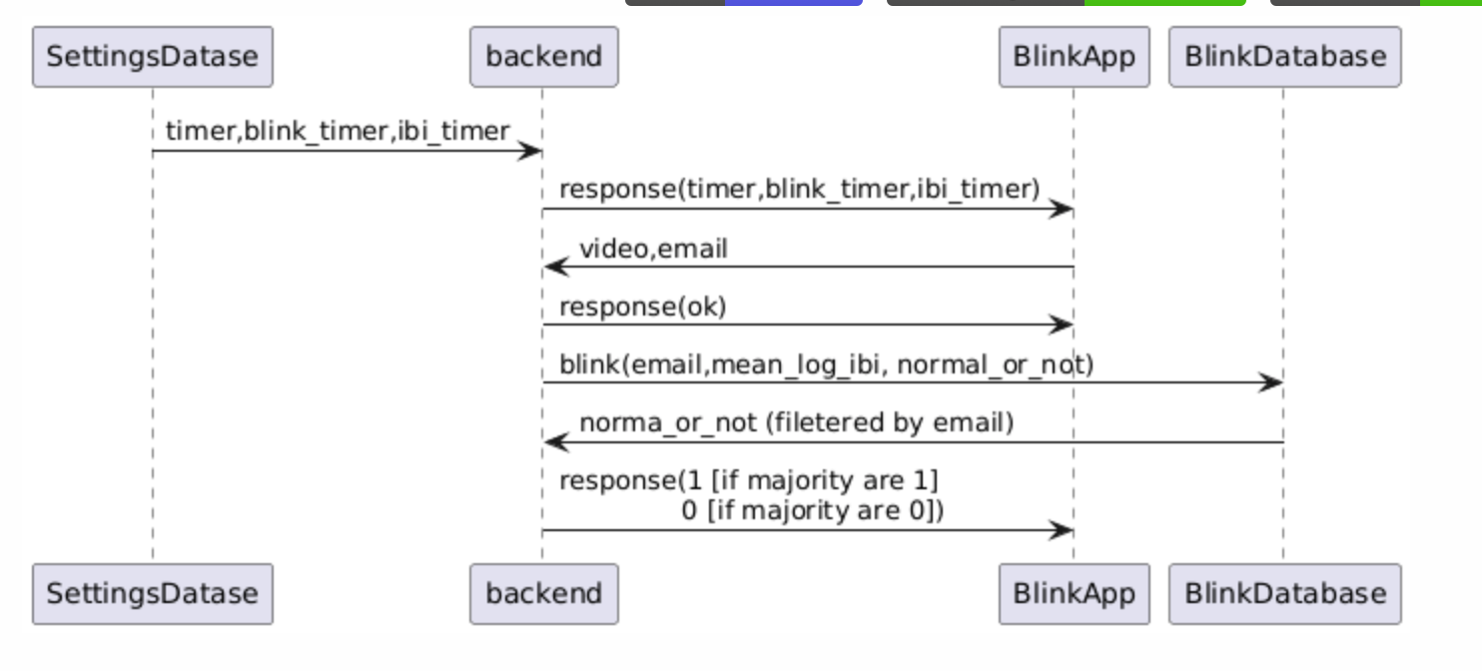
Image 22:data flow blink detections and breaks

Set Setting
User will submit a form with settings which will be sent to the backend via an API and will be stored in the SettingsDatabase with the primary key being the email.

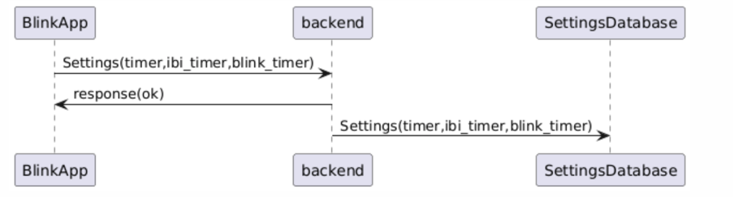
Image 23: data flow set settings

Statistics
Every time the user goes to this page, data from the BlinkDatabase is retrieved and displayed on a graph
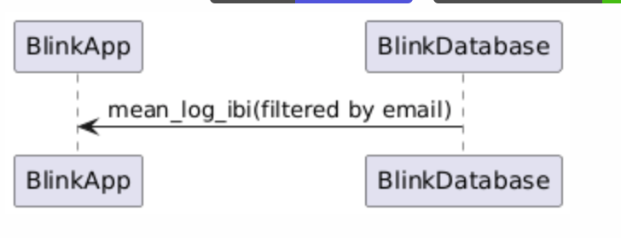
Image 24: data flow showing statistics

Testing strategy
Before developing the front end, I plan to test my APIs using Postman. Once the APIs are verified and the front end is built, I will perform unit testing on each component, ensuring alignment with the project objectives.

Technical solution

File structure
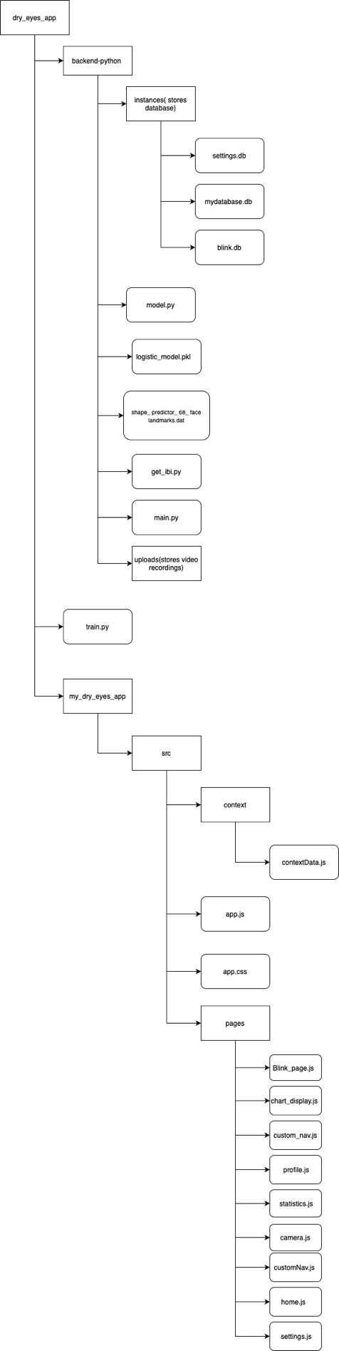
Image 25: file structure

Front end

App.js
This is main component that acts as the root of the component tree. This is where all the routing is present. This code allows the user to go from one page to another. Links different pages together (React, n.d.) (React, n.d.) (React, n.d.).

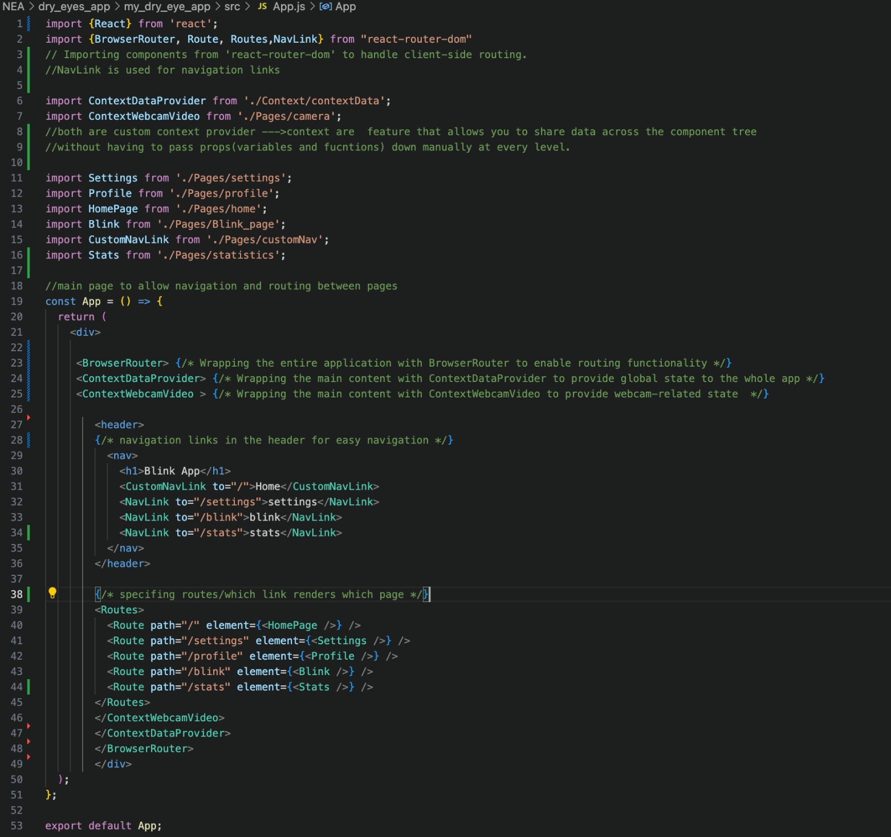
Code 1:App.js

Pages folder
The pages folder contains all the web pages that the user will see.

Home page (“/”)
This is the first page the user will see. They will get two options, create profile or already a user.
When “already a user” is pressed, unlike “create profile” button which sends the user to a different page, the “already a user” button just changes the existing page by setting the flag variable to 0 and shows the page below.

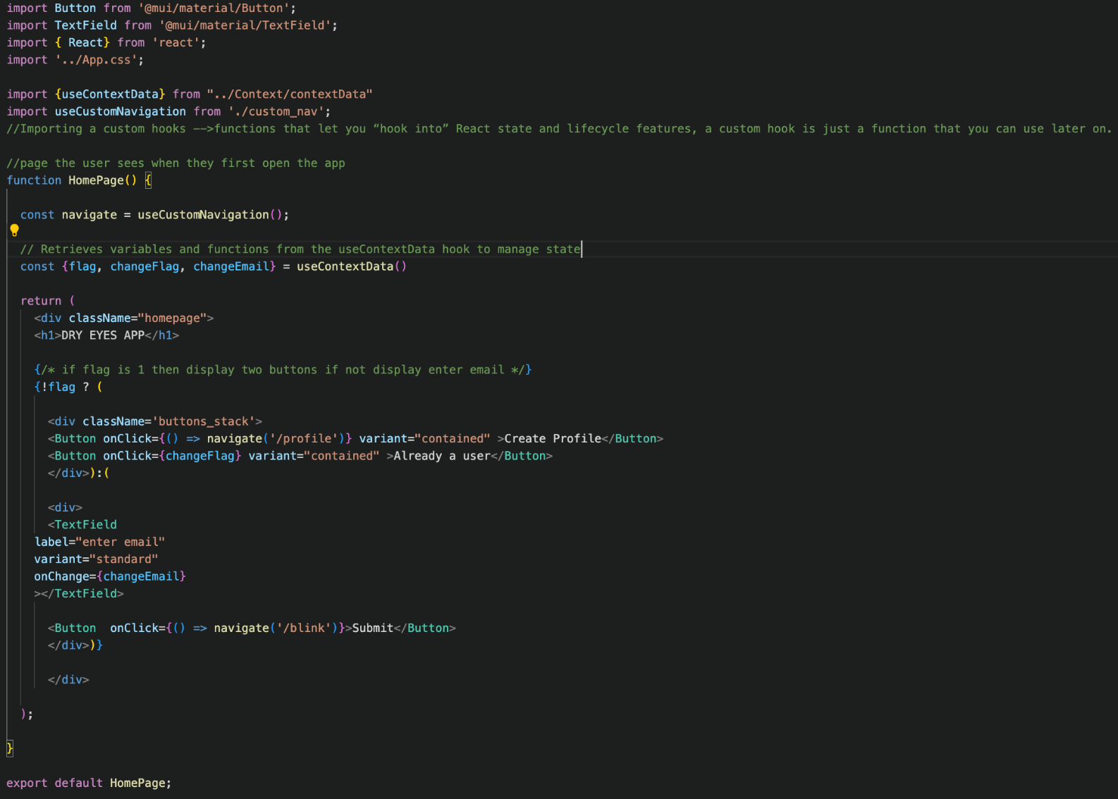
Code 2:Home page

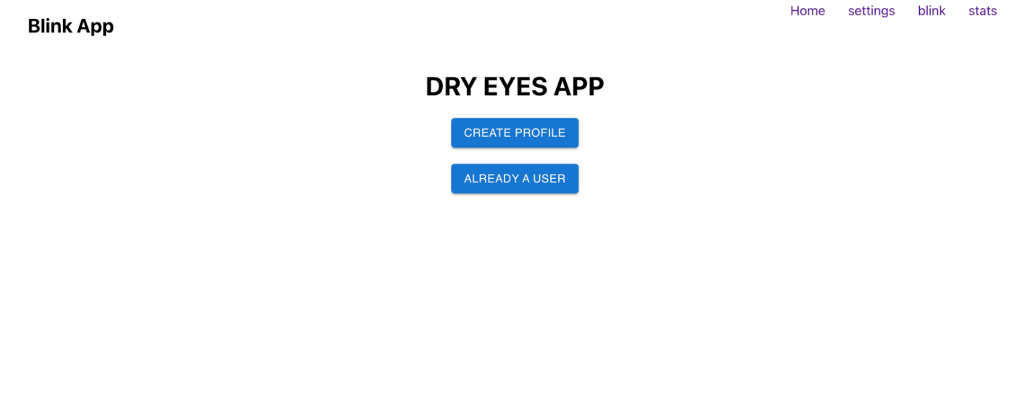
Image 26: home page

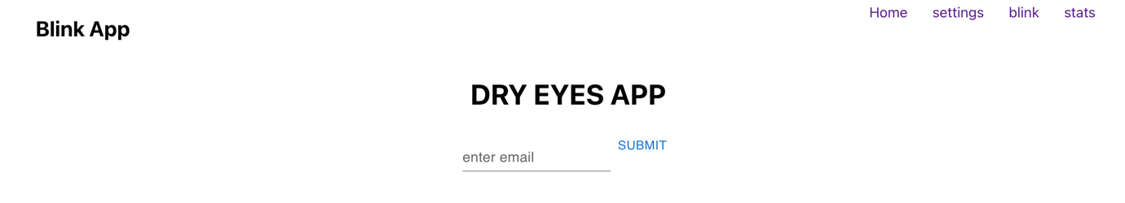
Image 27: log in page

Profile page(“/profile”)
Below is the code for the page profile where the user will be redirected to upon clicking the “create profile” button. This is where the user enters details such as email name and age, to uniquely identify the user. A post request is sent to the backend to store the new user with its information in the database. Validation is also handled here to ensure the data given is in correct format.

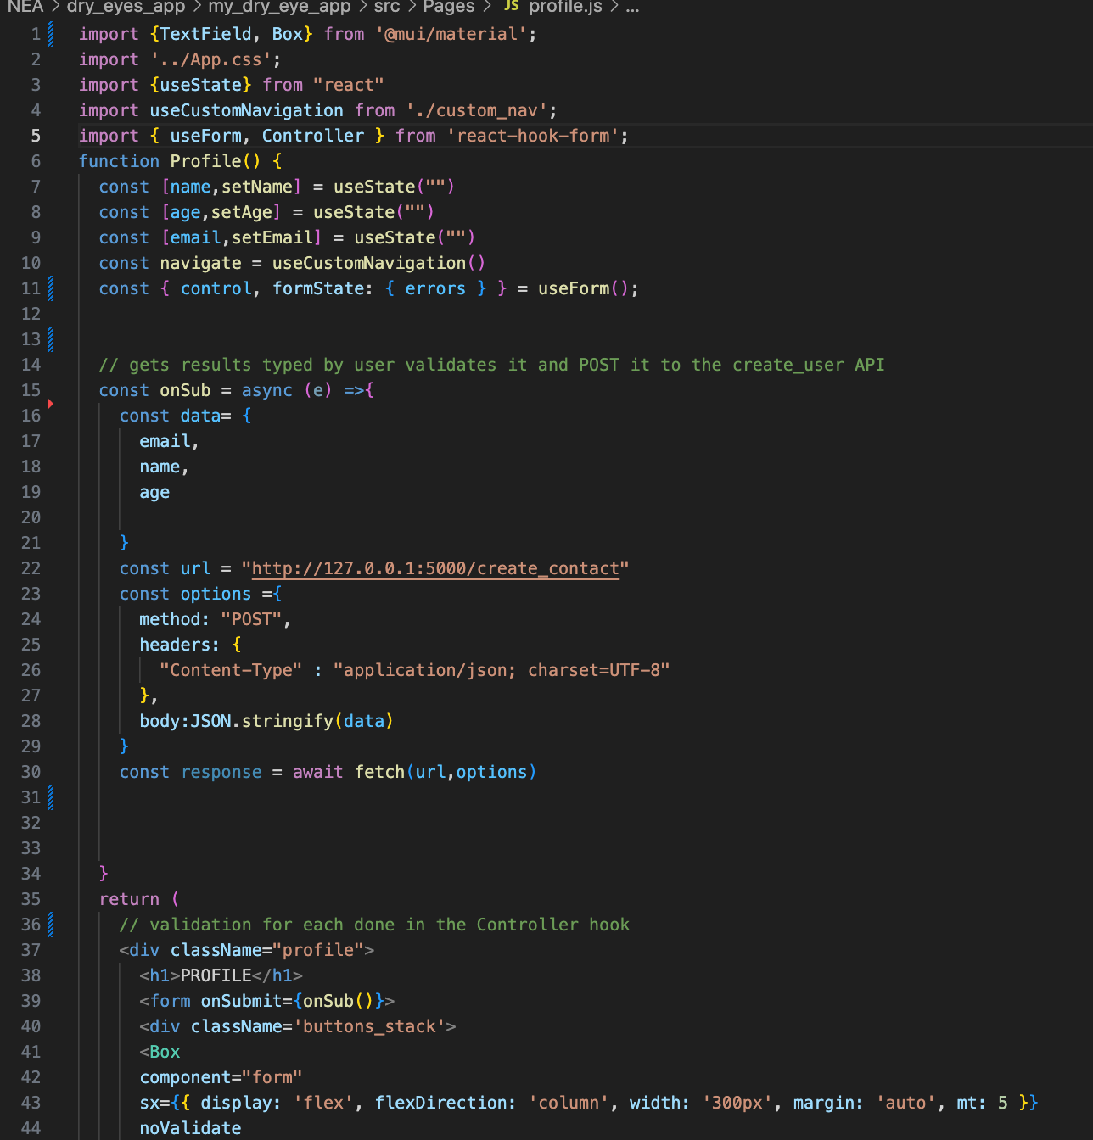
Code 3: profile page 1
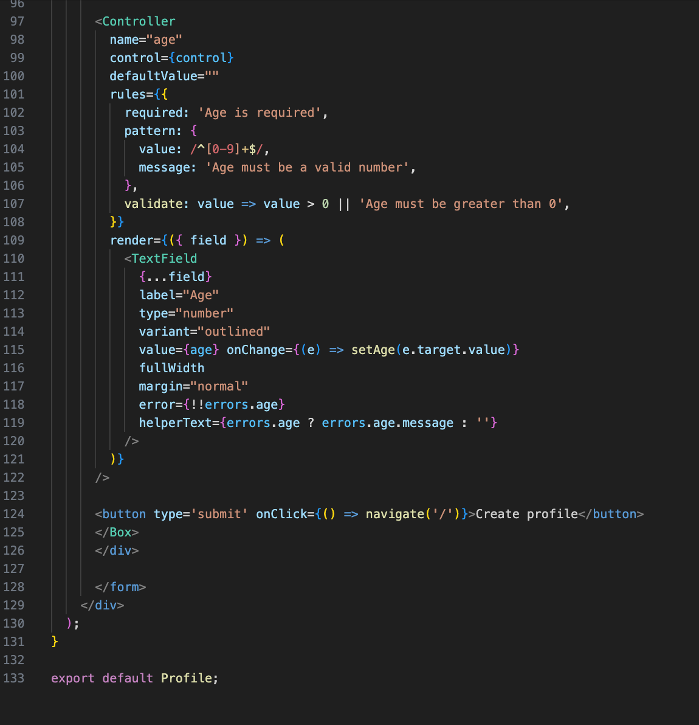
Code 4: profile page 2
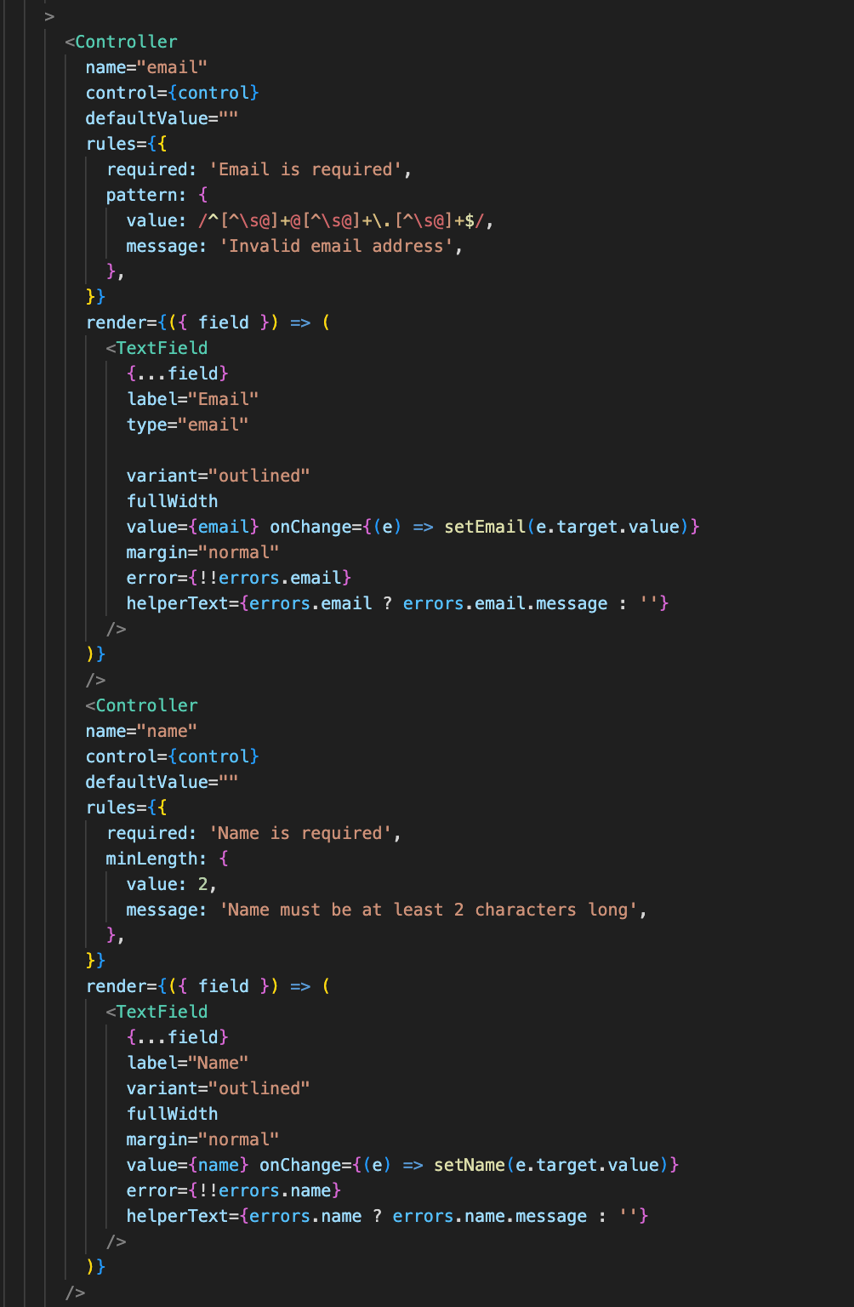
Code 5: profile page 3
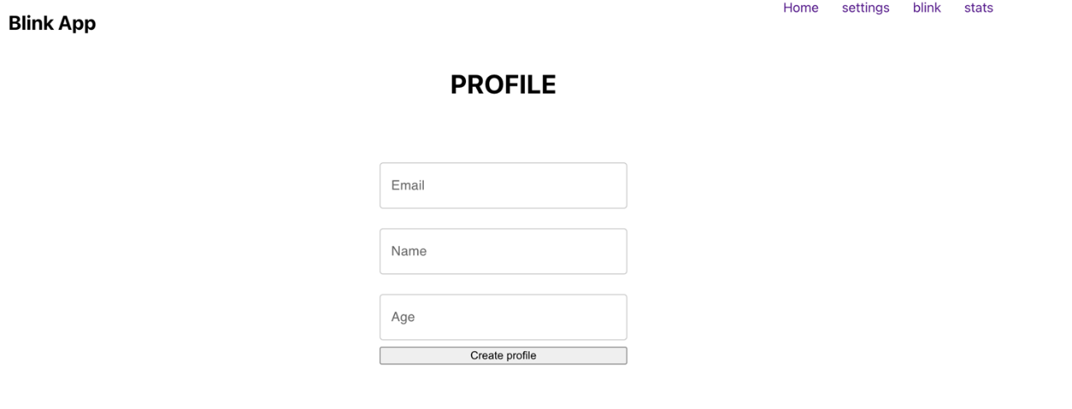
Image 28: profile page

Blink page(“blink”)
This is the main page where the user will see three options. Start, stop, stats button and settings (where stop button shows when start is pressed and vias versa). This page just shows these buttons, adds the users name to the top to let the user know that they are in their account. This is done by doing a parameterise get request where the parameter is the user’s email, and finds the name associated with that email in the database. This is also where a flag is used so that if the start button is pressed it will be replaced by stop and if the stop is pressed the start button replaces the stop button.
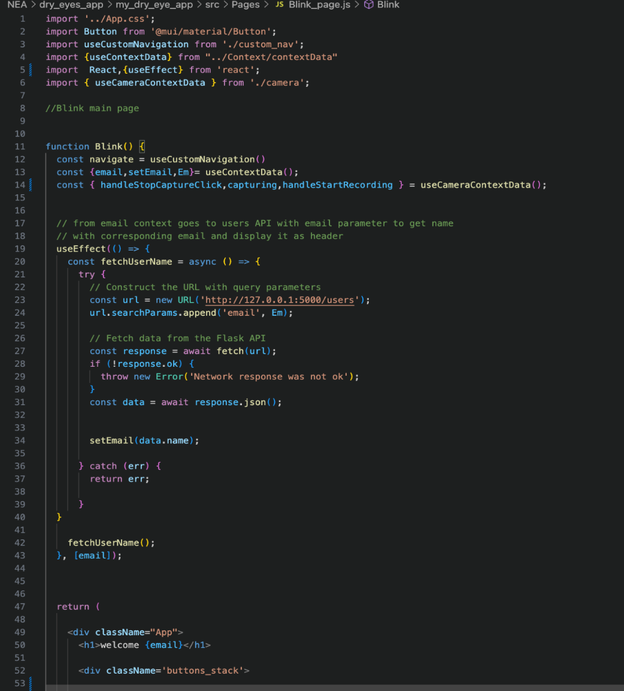

Code 6: blink page 1

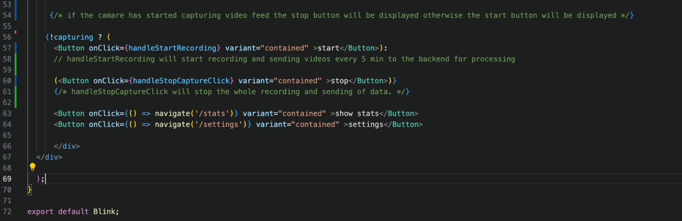
Code 7: blink page 2

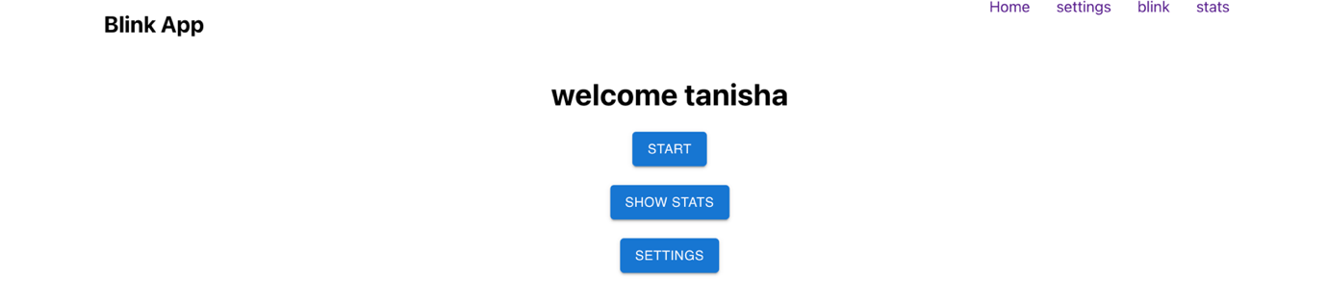
Image 29: blink page

Start button is clicked you see the following bellow

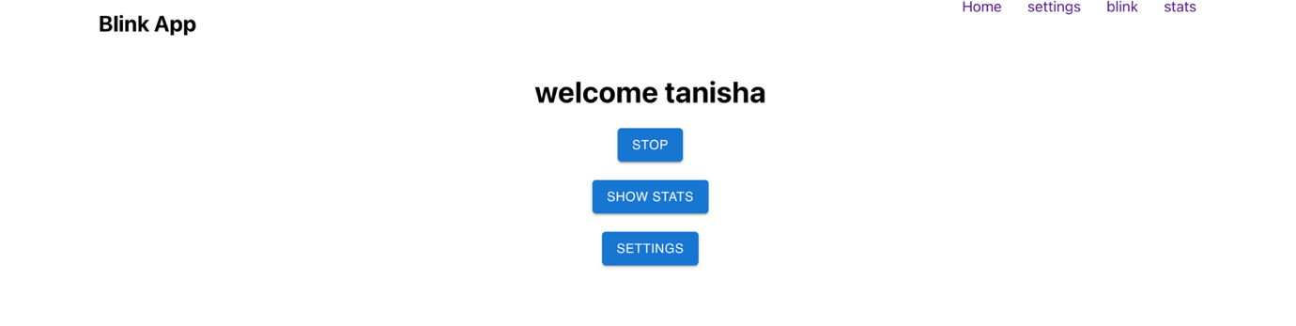
Image 30: blink page

Settings page (“/settings”)

This is the settings page where the user can change the settings of the various timers. One is the blink timer which determines how long each video recording should be before being sent to analyse to the backend. IBI timer is the duration of time that is waited before checking wither to start a break timer or not. And finally, timer is the duration the break will last. This page also shows the user their current settings.
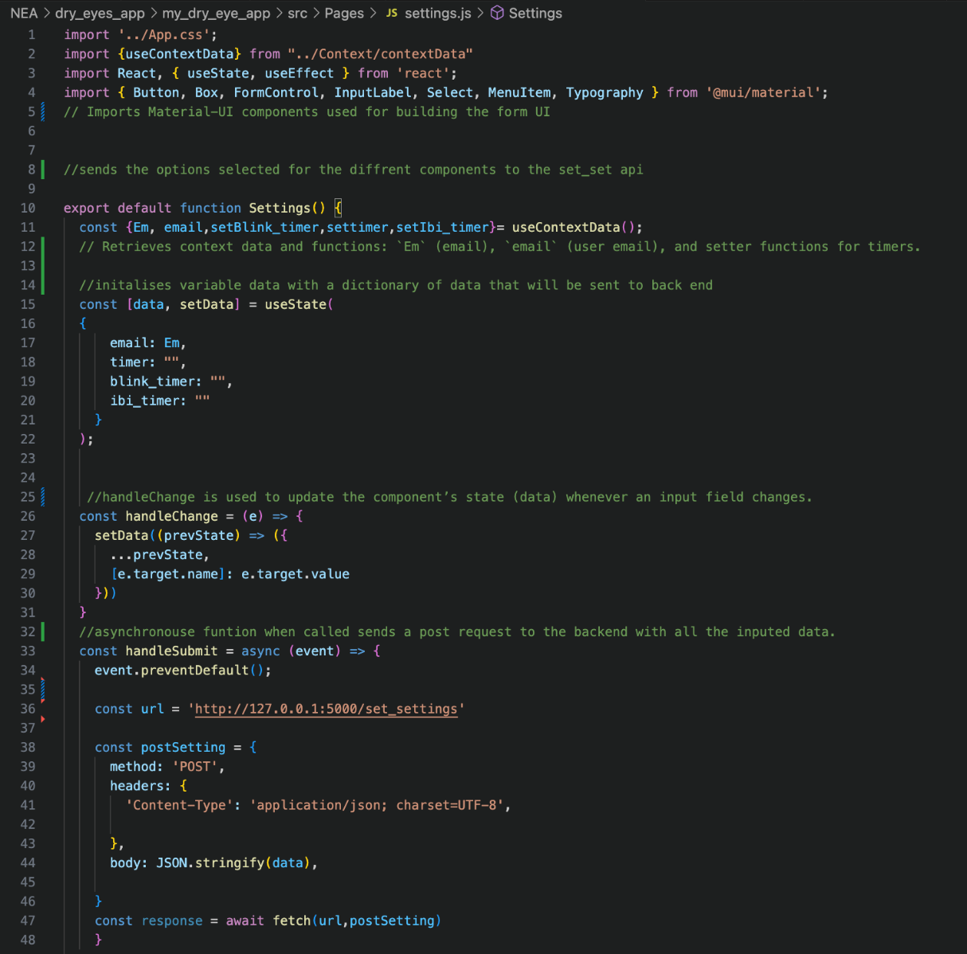
Code 8: settings page 1
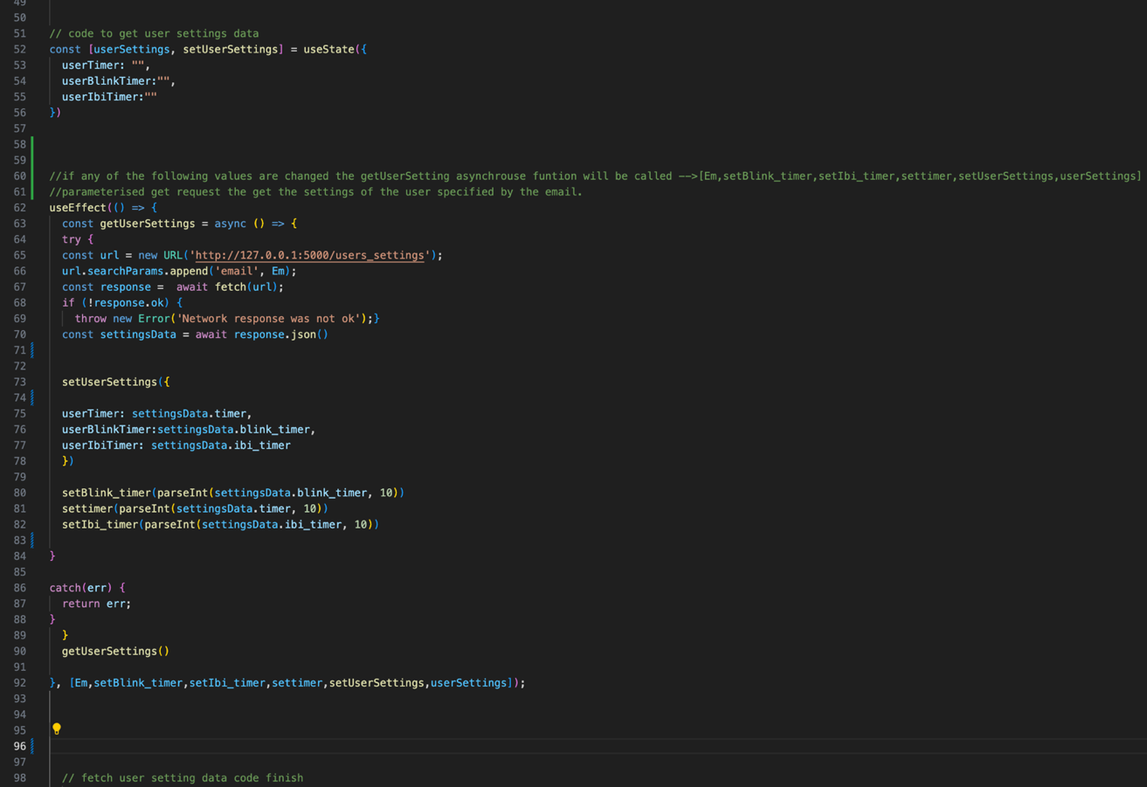
Code 9: settings page 2
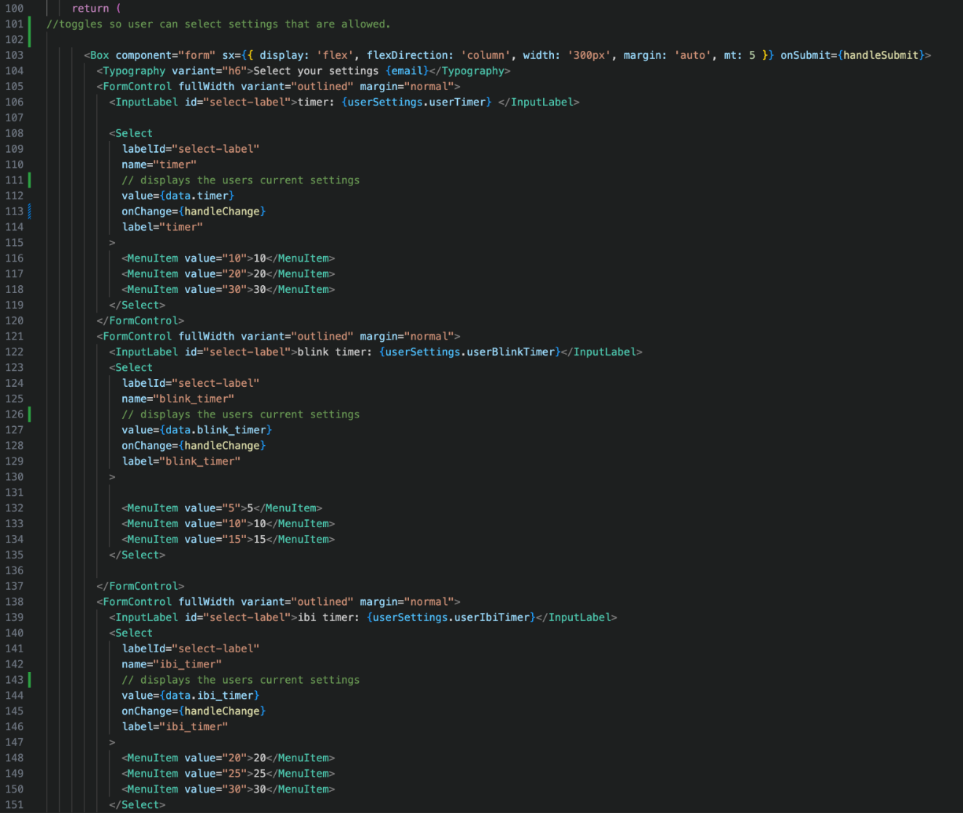
Code 10: settings page 3
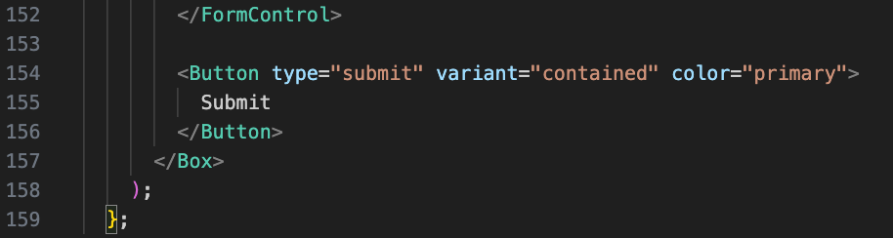
Code 11: settings page 4

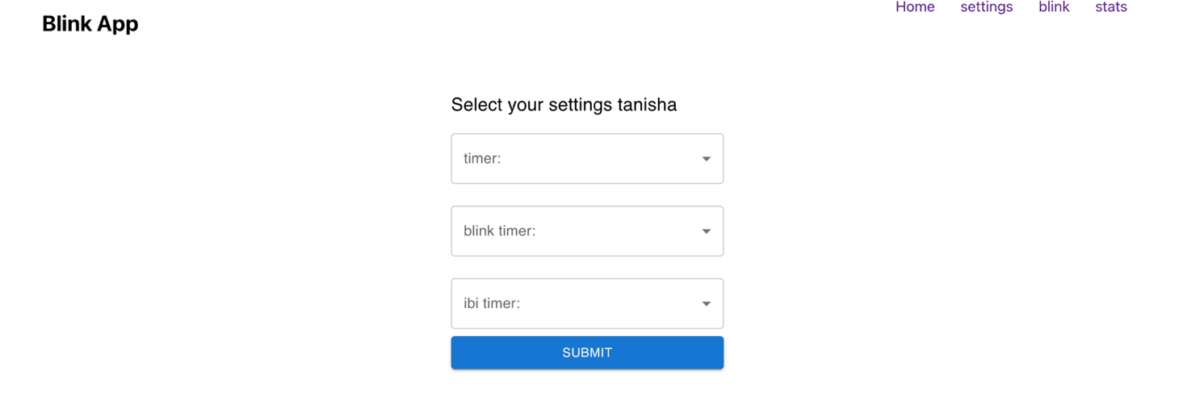
Image 31: settings page

Stats page (“stats”)

This is the stats page, where the user can see how their blink rate differs over time. The graph is updated in real time and shows the mean_log_ibi over time.

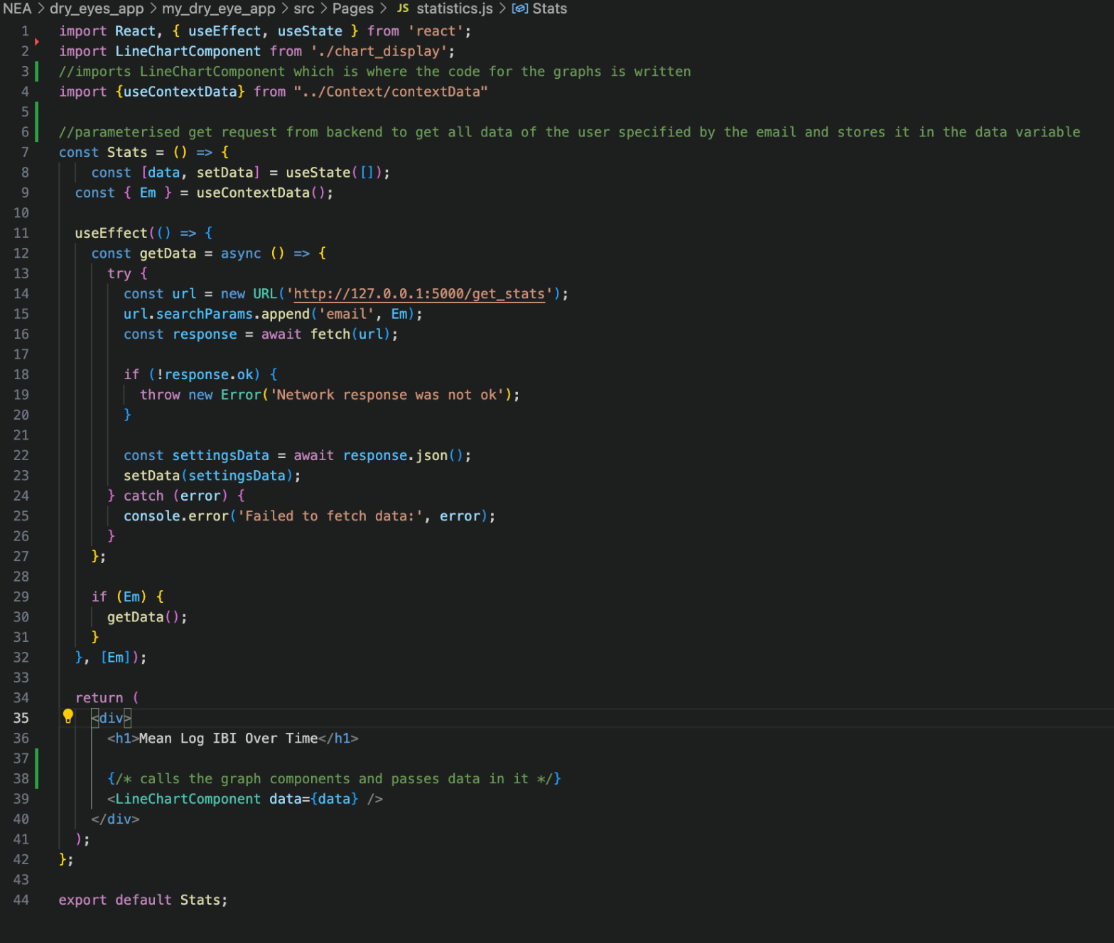
Code 12: stats page 1
The LineChartComponets uses ChartJs which is a popular JavaScript library used to create interactive, customizable charts and graphs on web pages. It provides a simple API for creating various types of visualizations, such as line charts, bar charts, pie charts, radar charts, and more.

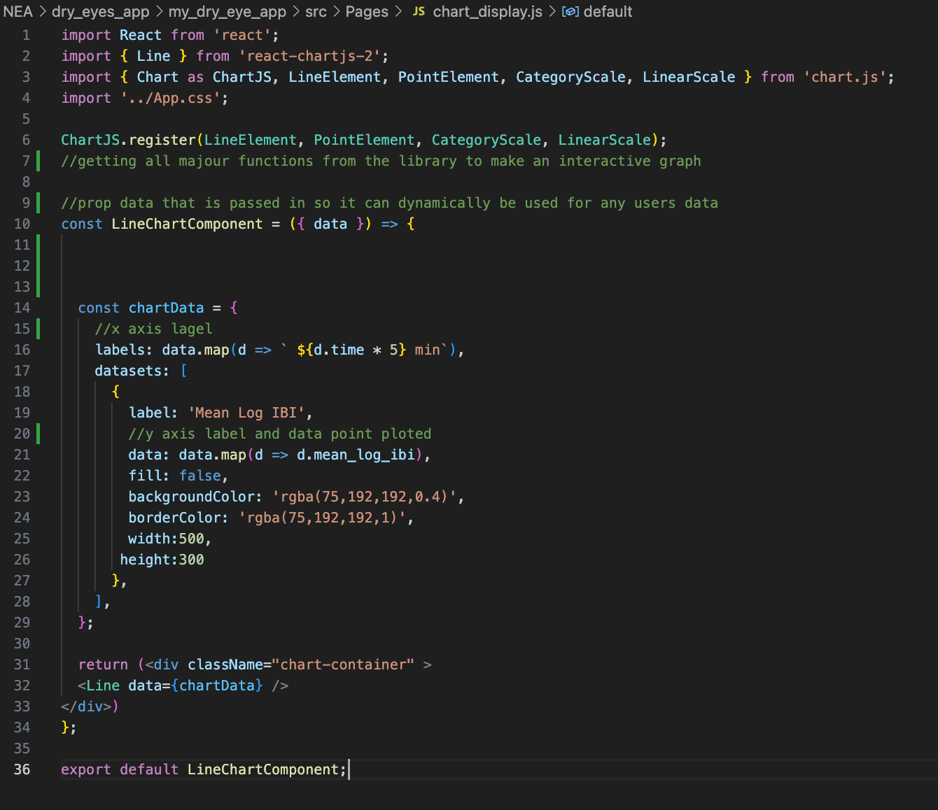
Code 13: stats page

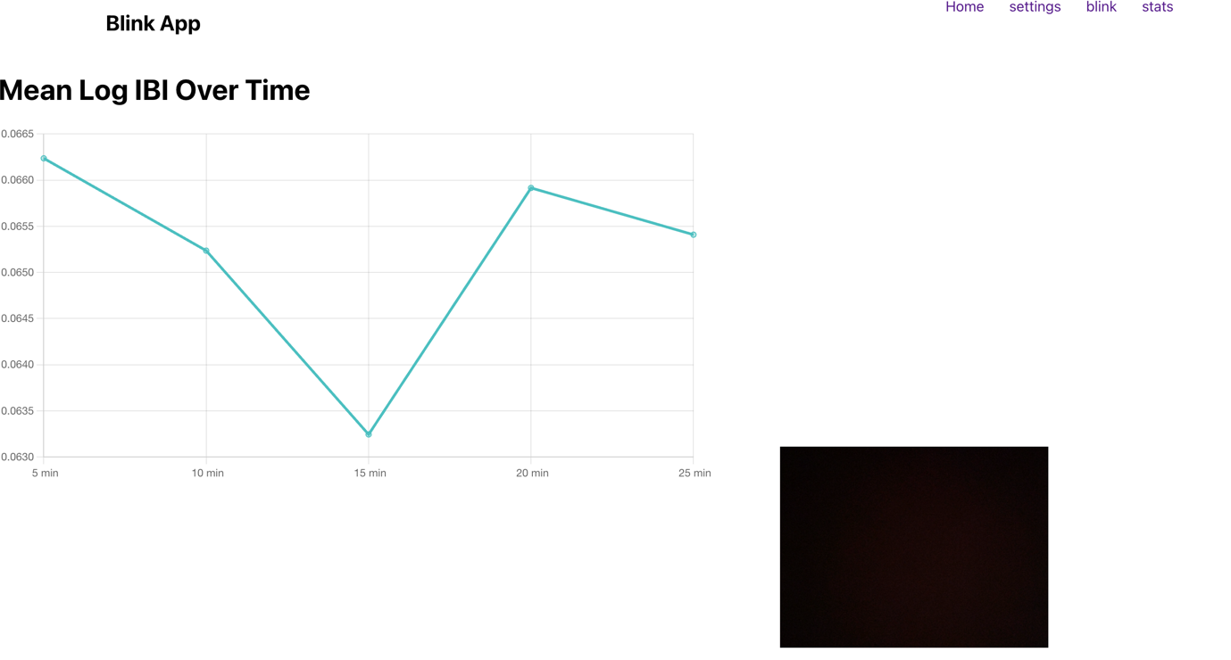
Image 32: stats page

Camera context

The following is where most of the break timer logic is present and is where the recording and sending of the user video is sent to the backend for processing. This is also where the results are retrieved to be used to determine if a break should be taken or not. And finally, where the break timer is defined.

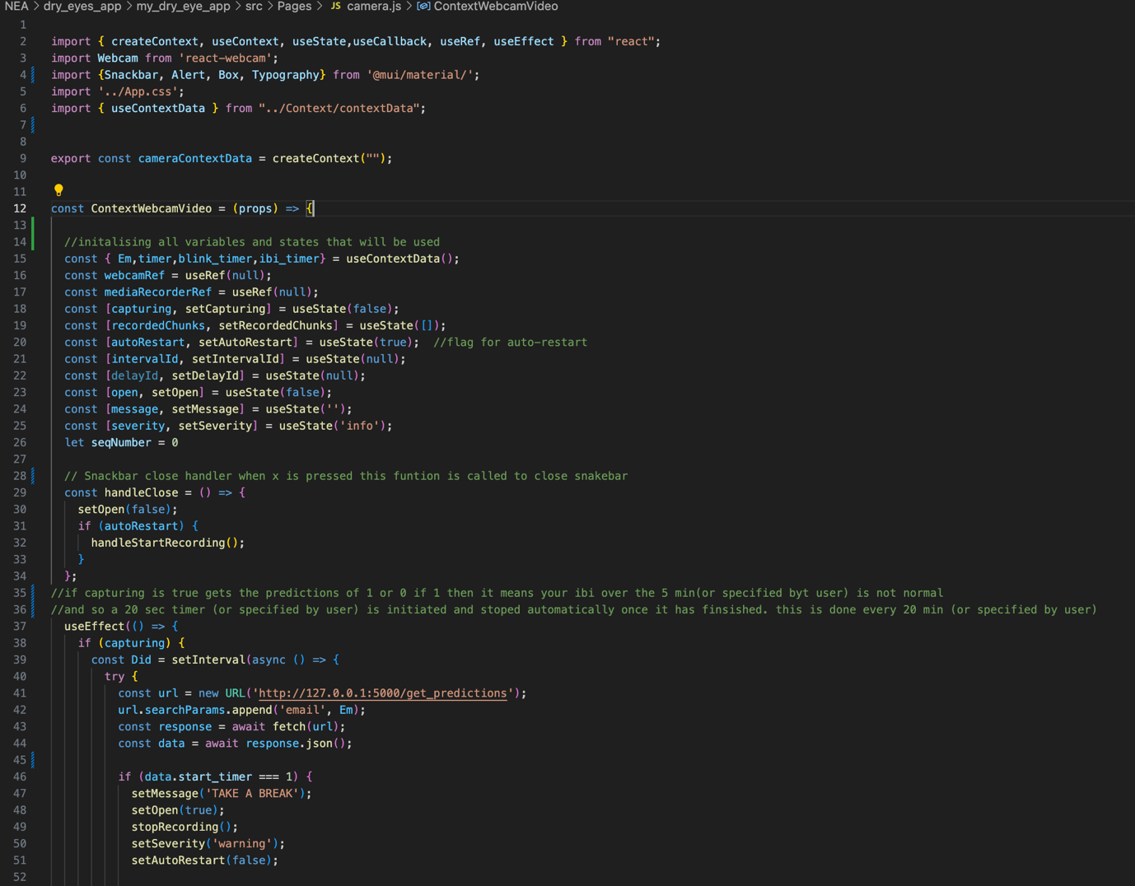
Code 14: video recording, Break 1
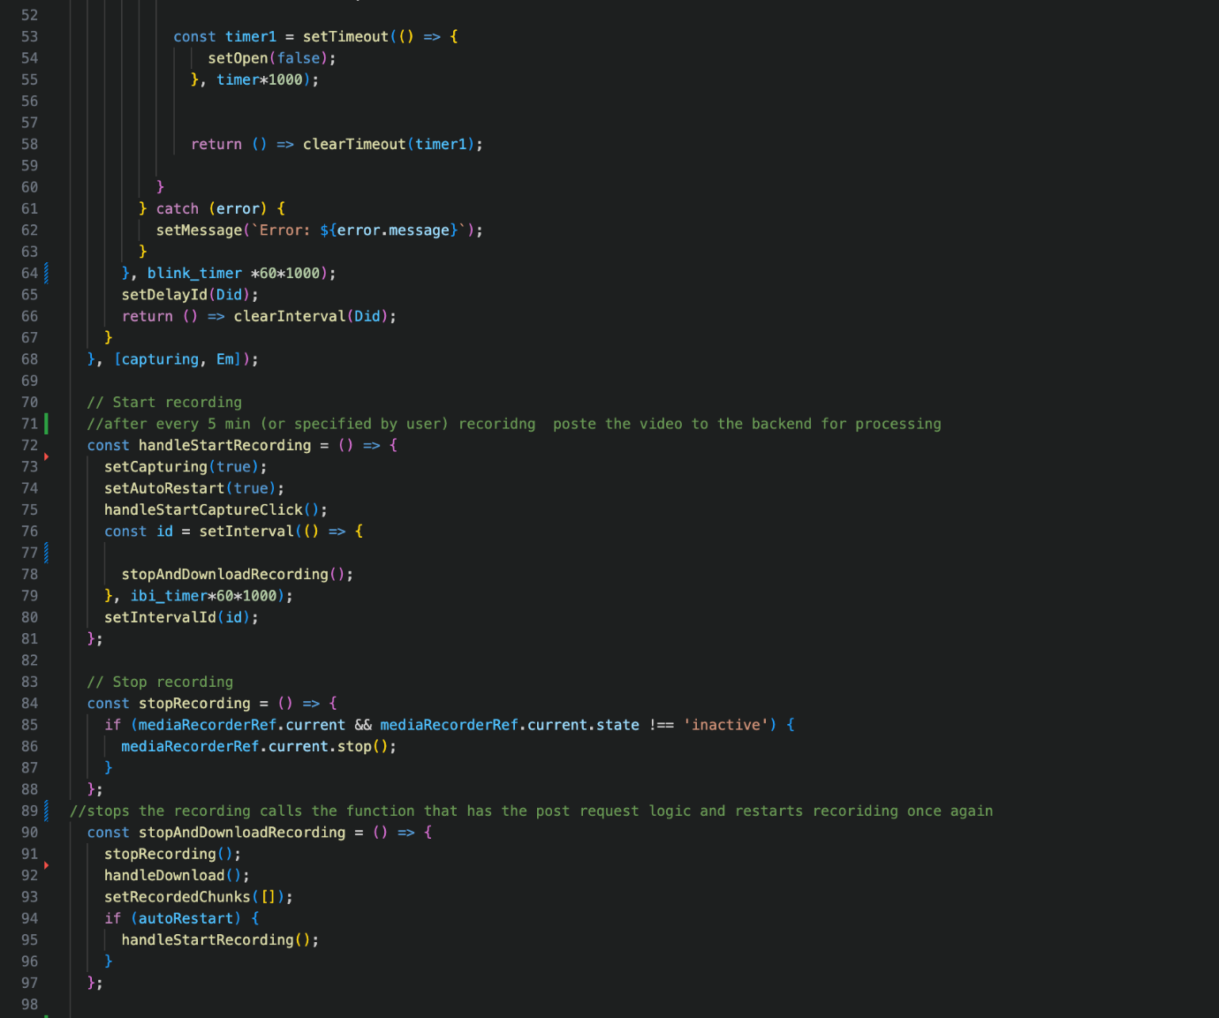
Code 15: video recording, Break 2

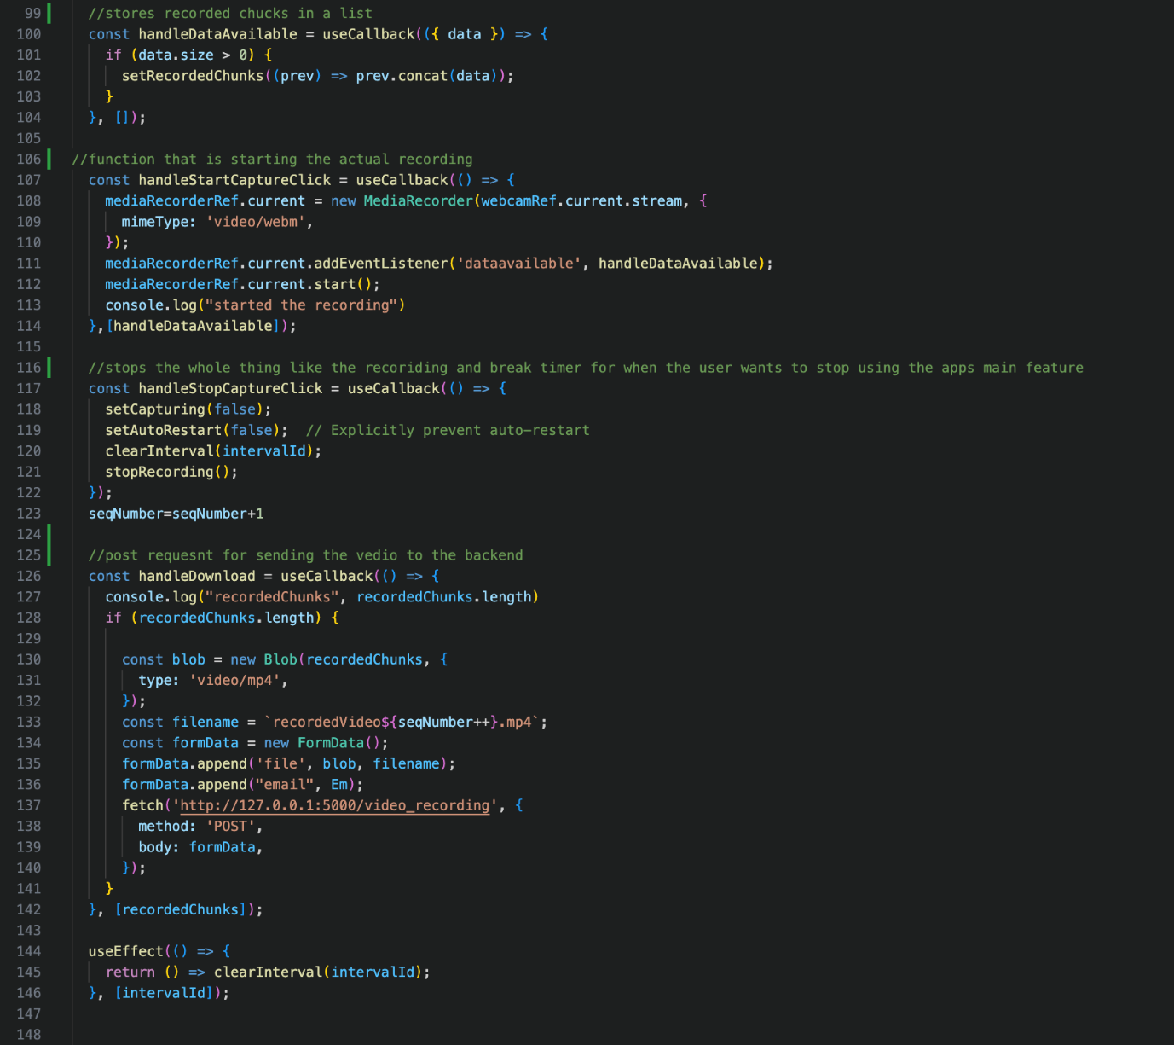
Code 16: video recording, Break 3

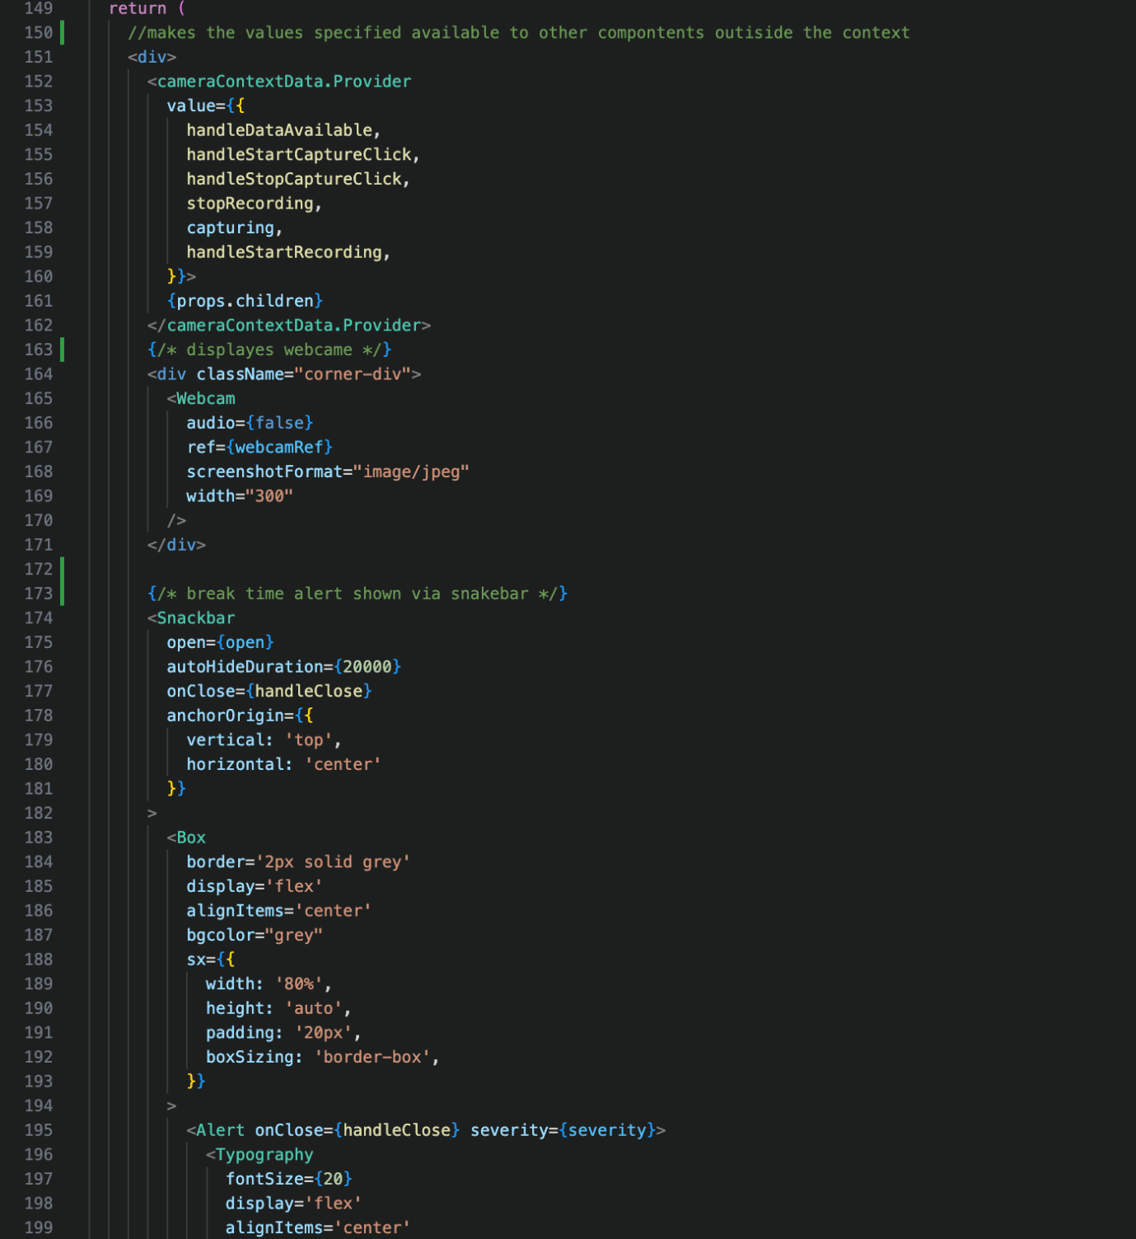
Code 17: video recording, Break 4
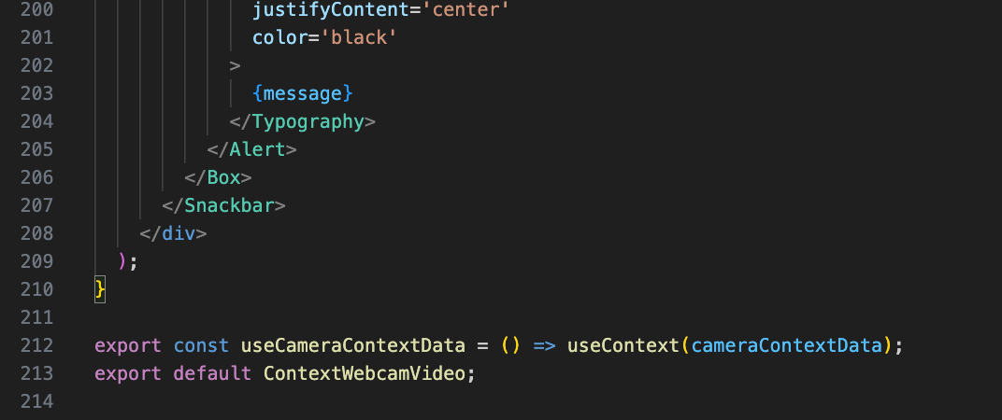
Code 18: video recording, Break 5
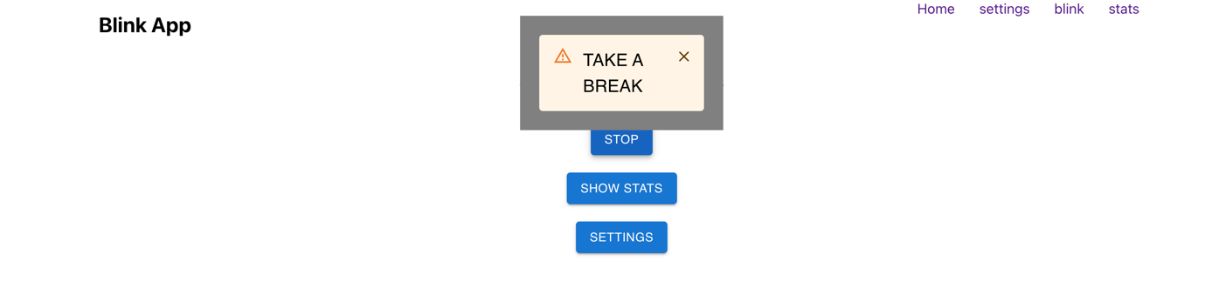
Image 33: break alert

Custom nav
This allows me to navigate between different pages and is shown at the top right corner of every page.

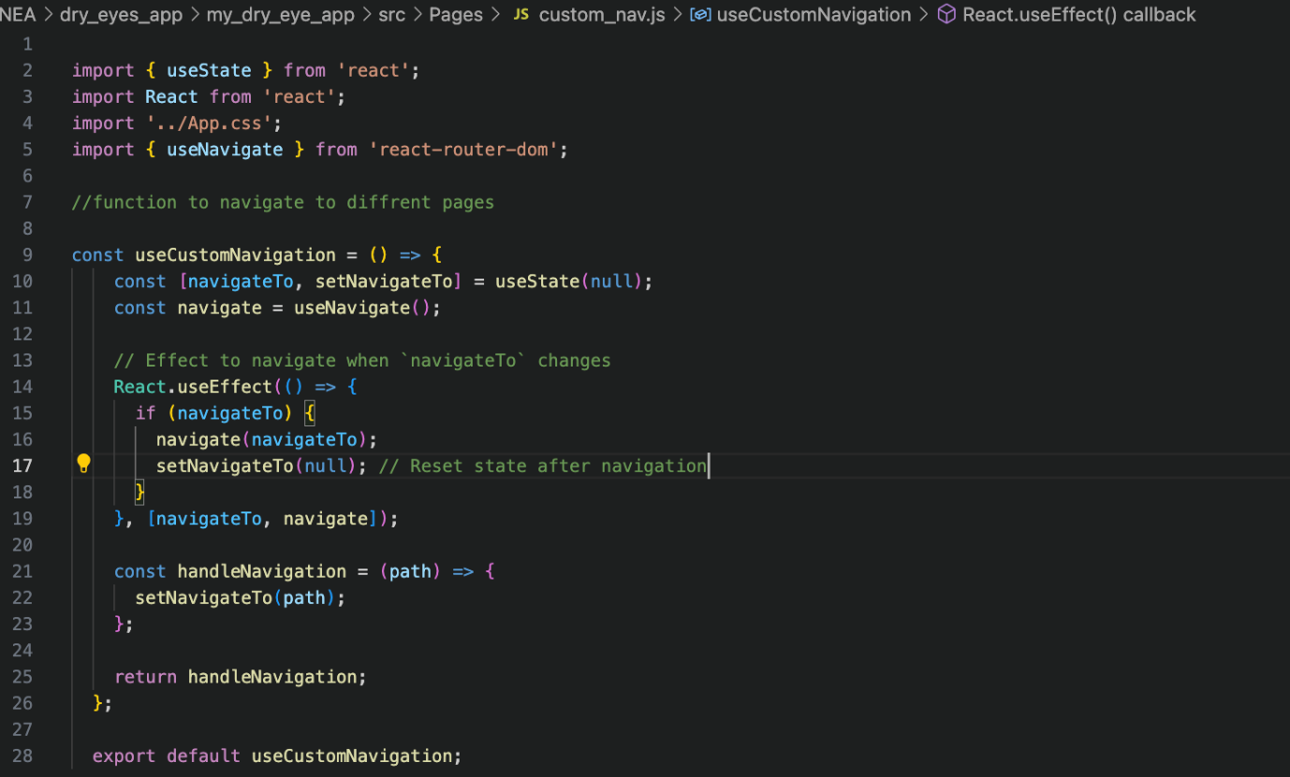
Code 19: nav bar

Context folder

Context data

Holds all variables and functions that will be needed in other components and should carry the same state throughout all components. Like defining your own module.

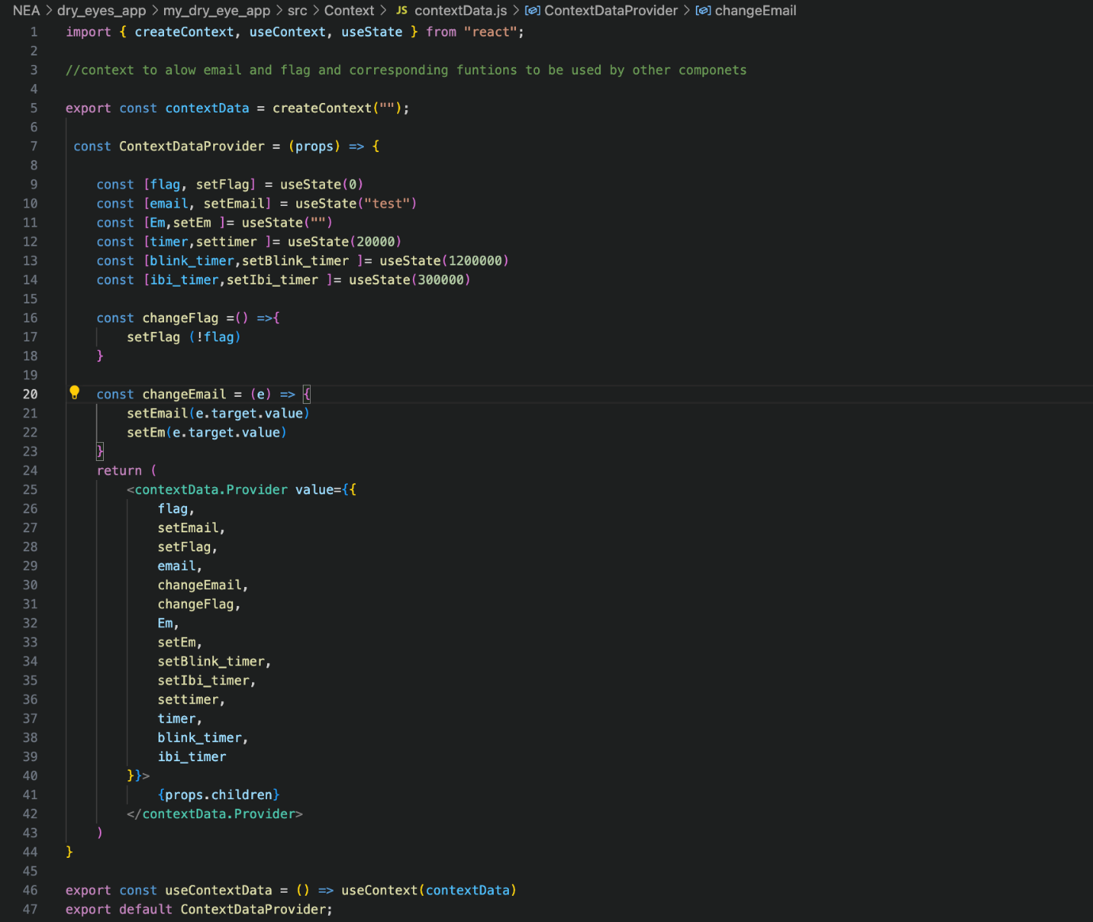
Code 20: context data

Backend code

Flask app

Main.py

This is where all my APIs are defined and where all things tie together such as processing of video to get blinks and IBI, predicting if its normal or not and querying and adding to databases (Flask, n.d.).
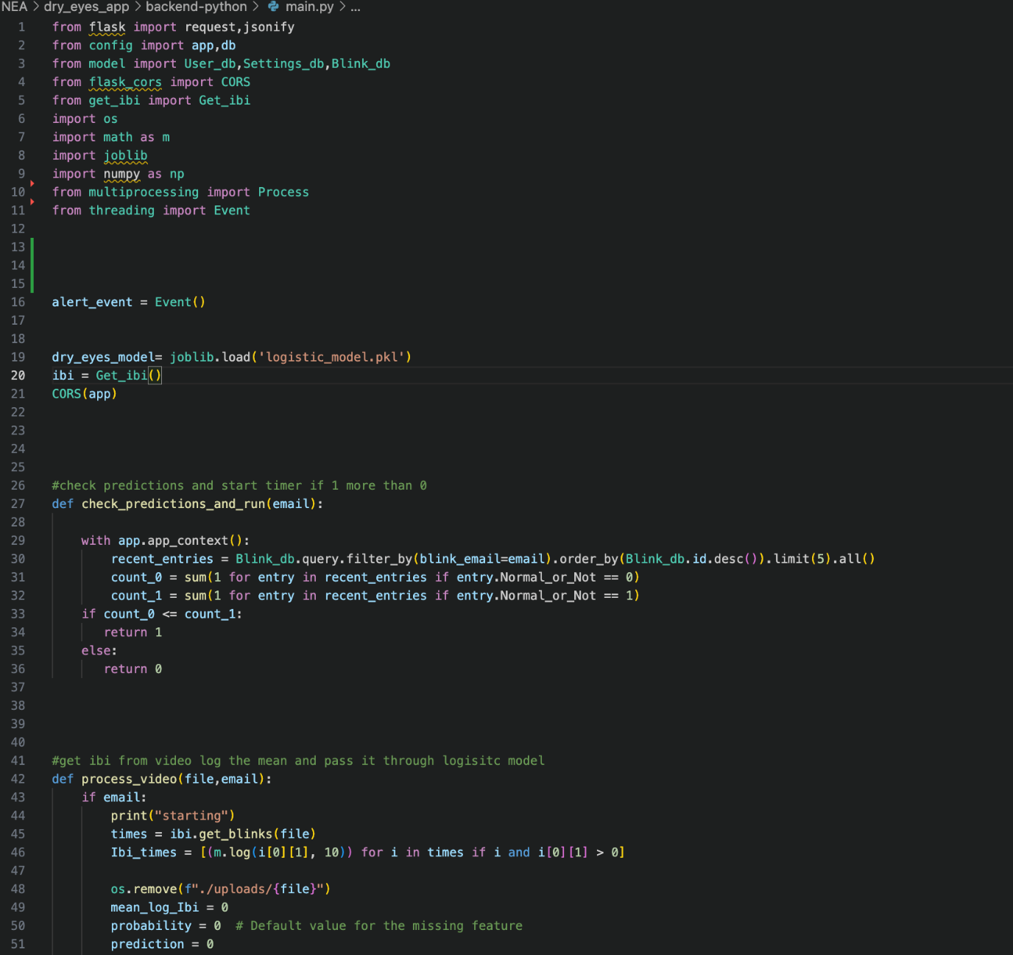
Code 21: API's 1
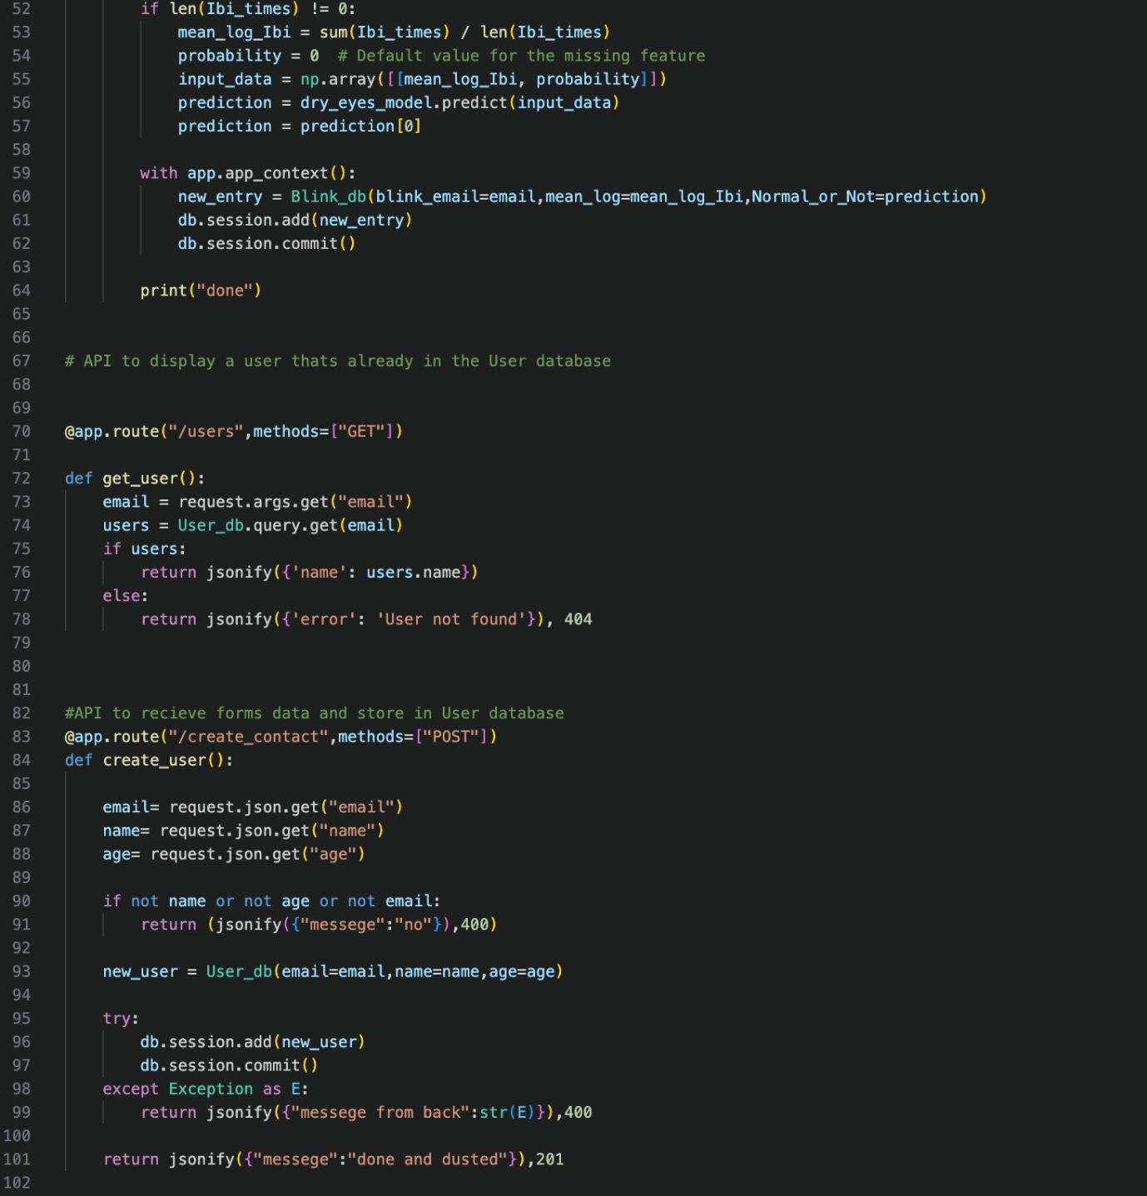
Code 22: API's 2
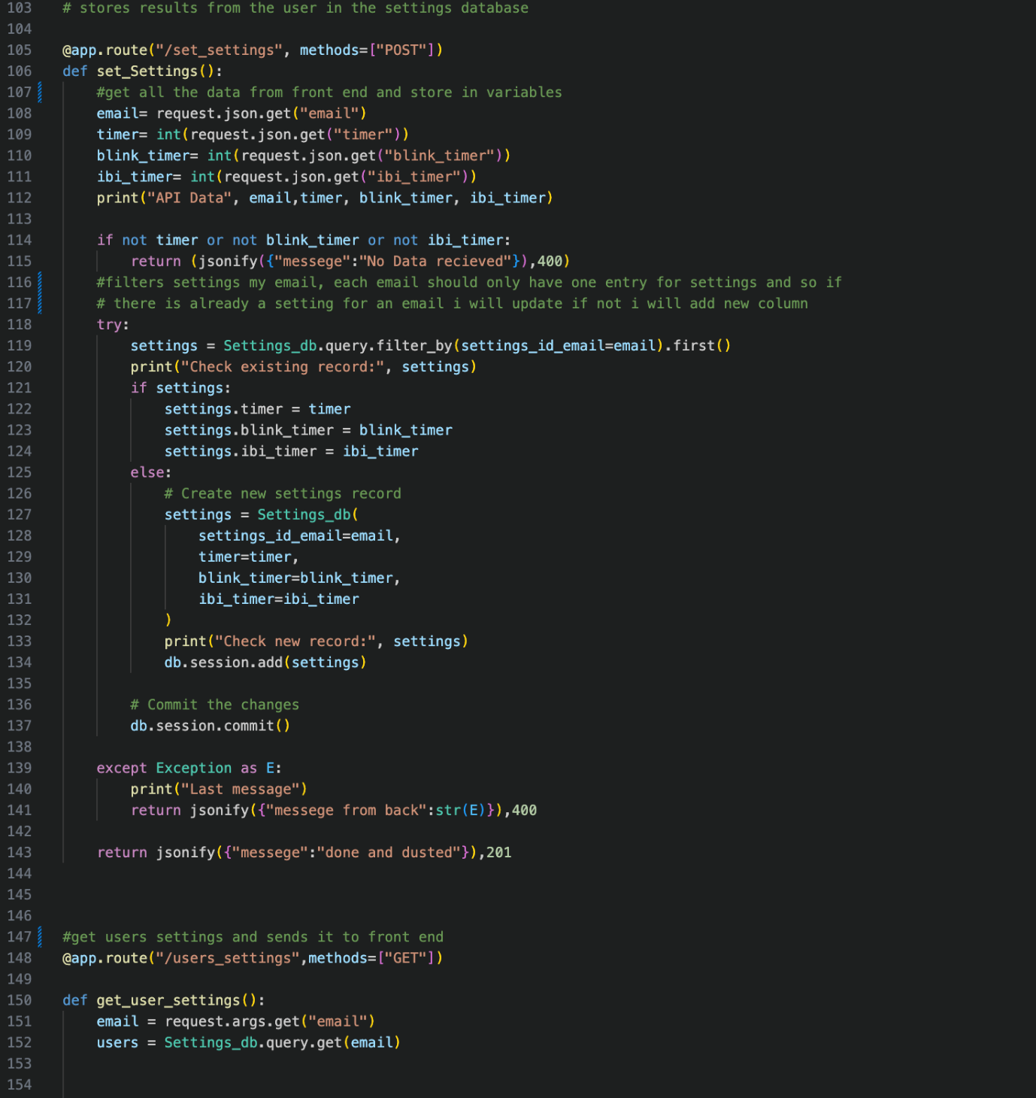
Code 23: API's 3
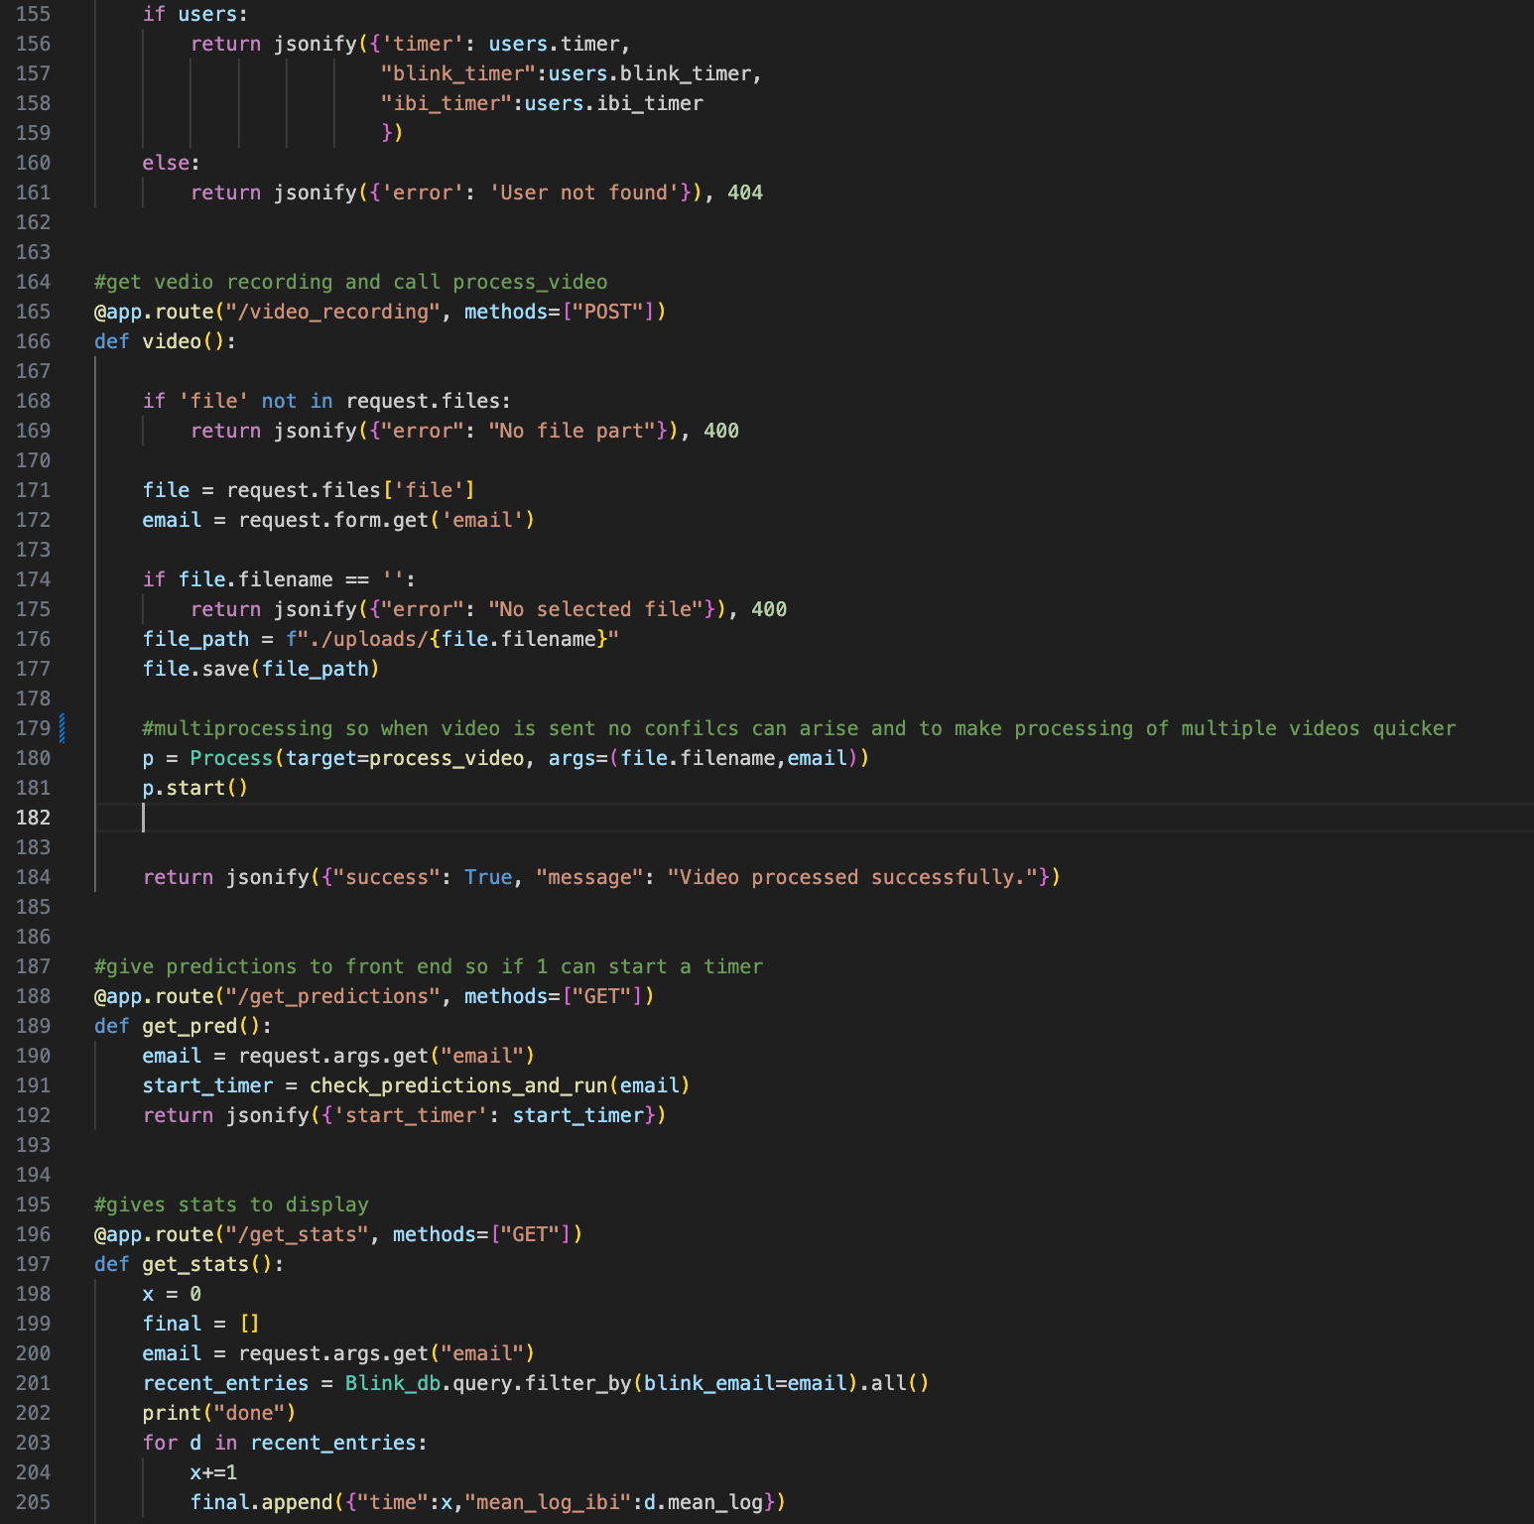
Code 24:API's 4

Multiprocessing is used here. Let’s take an example of each video that is being sent to analyse is 5 min long. The time it takes to process that video and find the IBI is more that 5 min long and so it doesn’t finish being processed before the next video is sent of analysing. This cause confliction and to stop that I decided to use multiprocessing (details here and here).
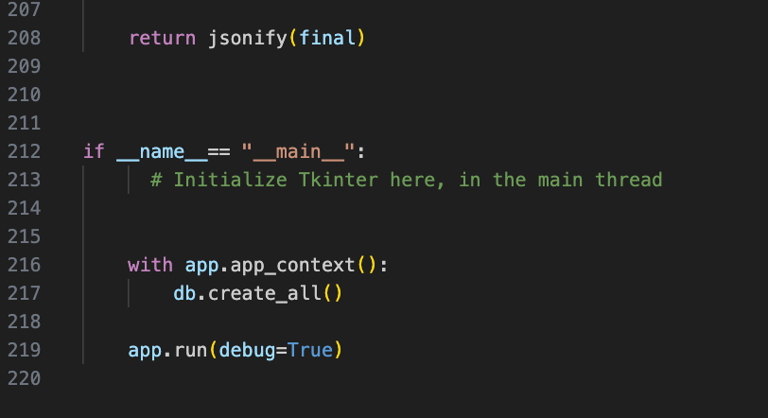
Code 25: API's 5

Models.py and config.py

Models.py is where I define my databases. Config.py is where I do all configurations for my flask app and models.

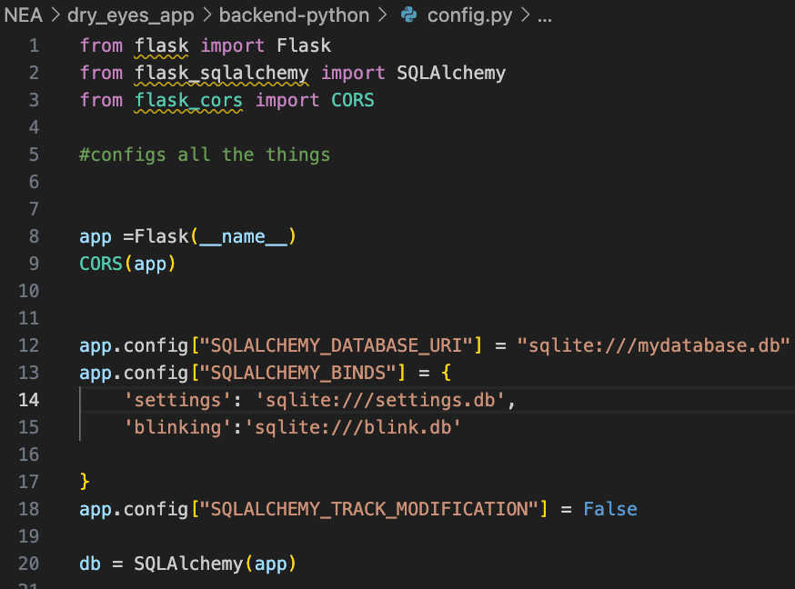
Code 26: flask app configuration
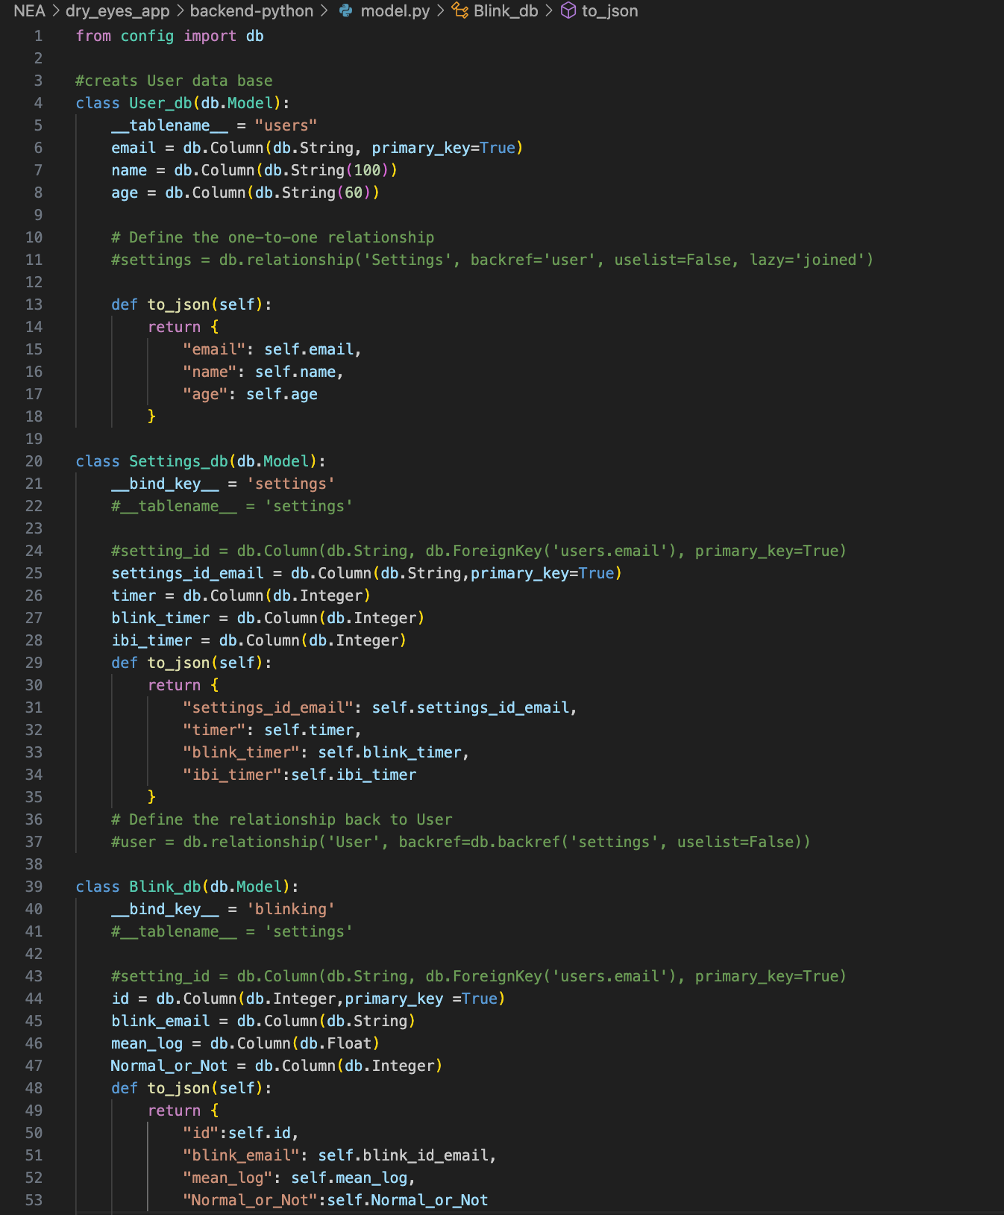
Code 27: defining database

Blink detection class

This is where I detect blinks and store IBI in a hash table for easier retrieval later (Geeks for Geeks, n.d.) (Flask, n.d.).
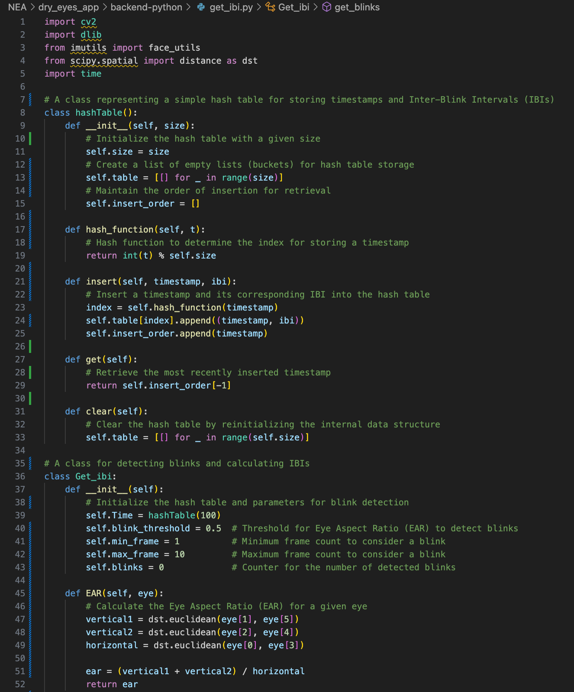
Code 28: blink detection and IBI calculation 1
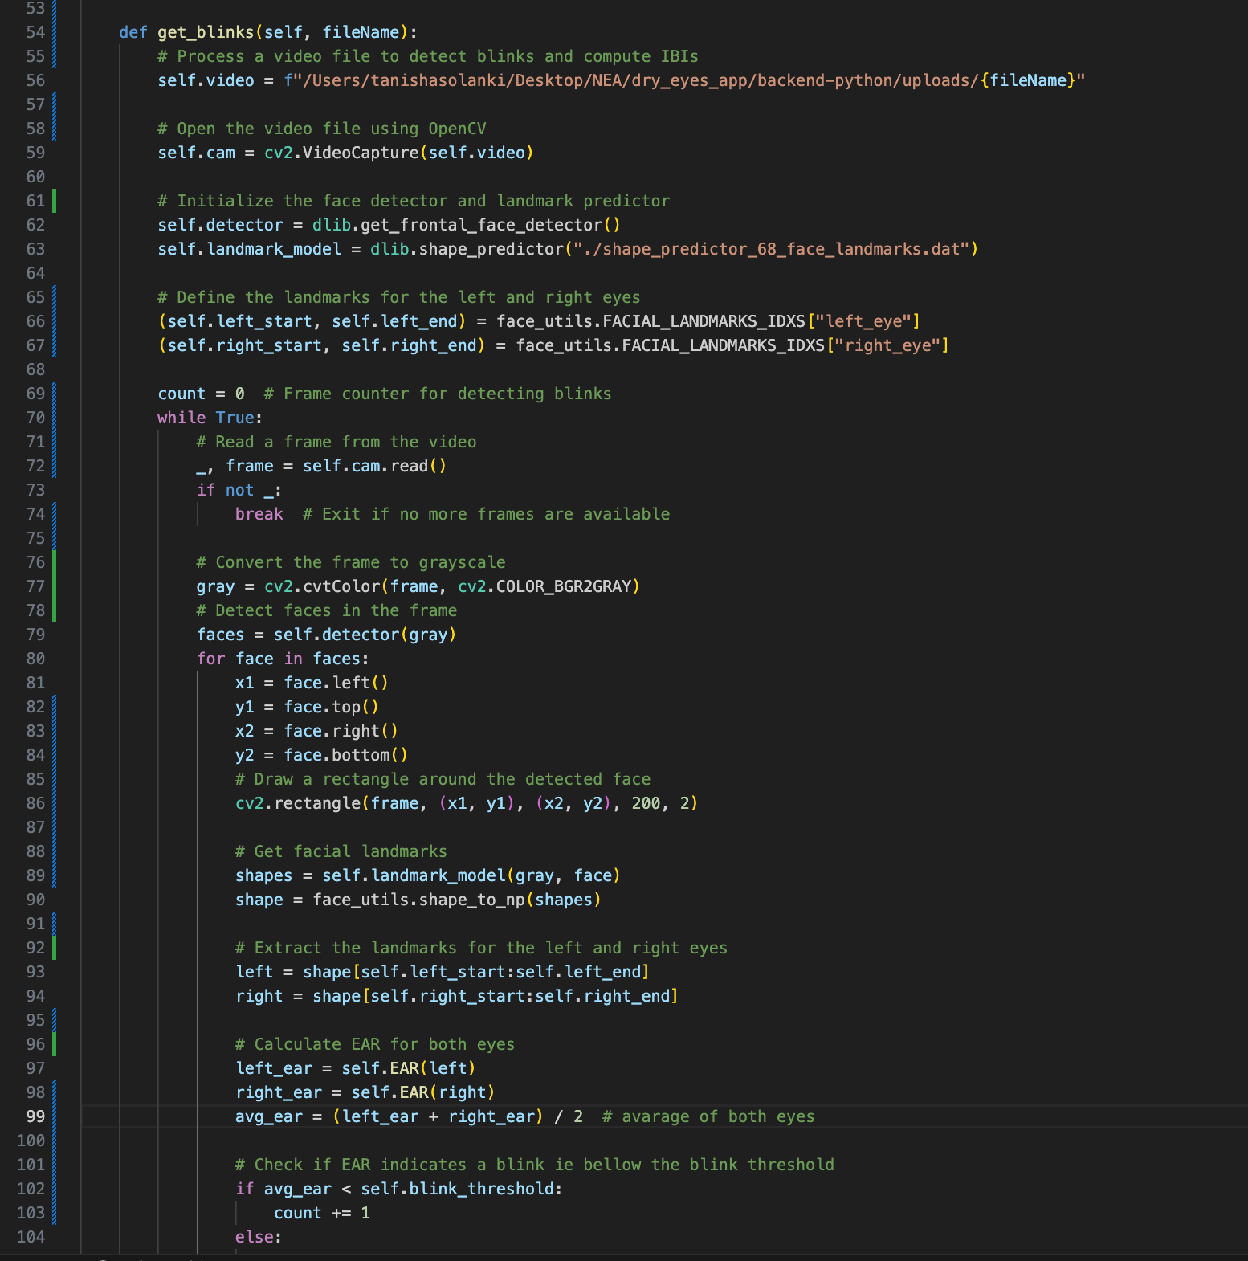
Code 29:blink detection and IBI calculation 2
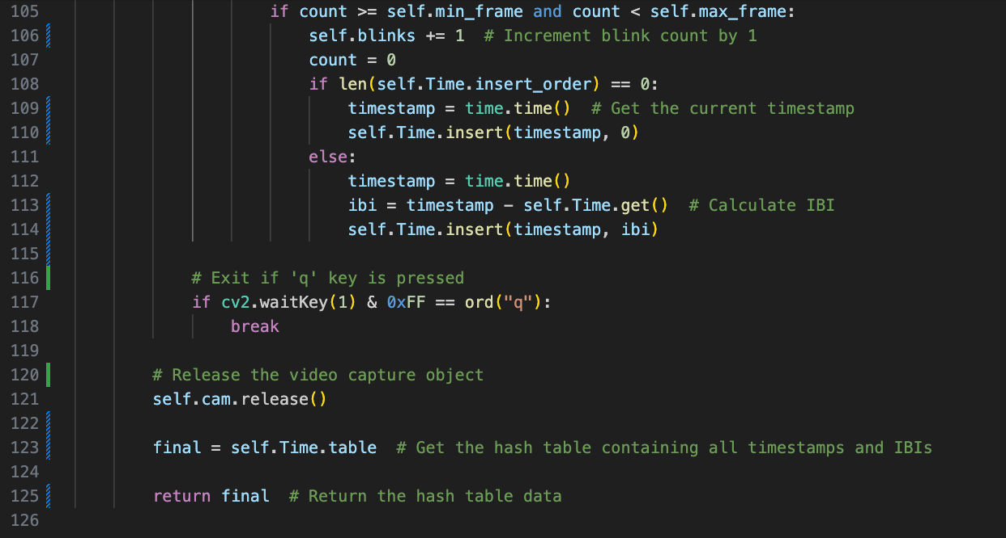
Code 30:blink detection and IBI calculation 3

Logistic regression model

This is the code used to train my logistic regression model. This code is only used once. The trained model will be used, by taking in the mean_log_ibi and determining if it is of a normal person or if it is of a person with dry eyes.

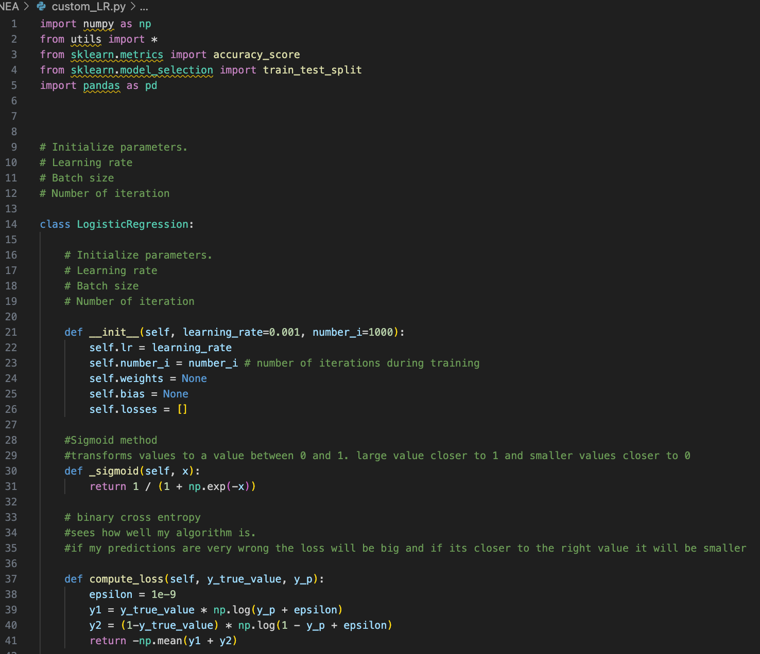
Code 31: logistic regression 1
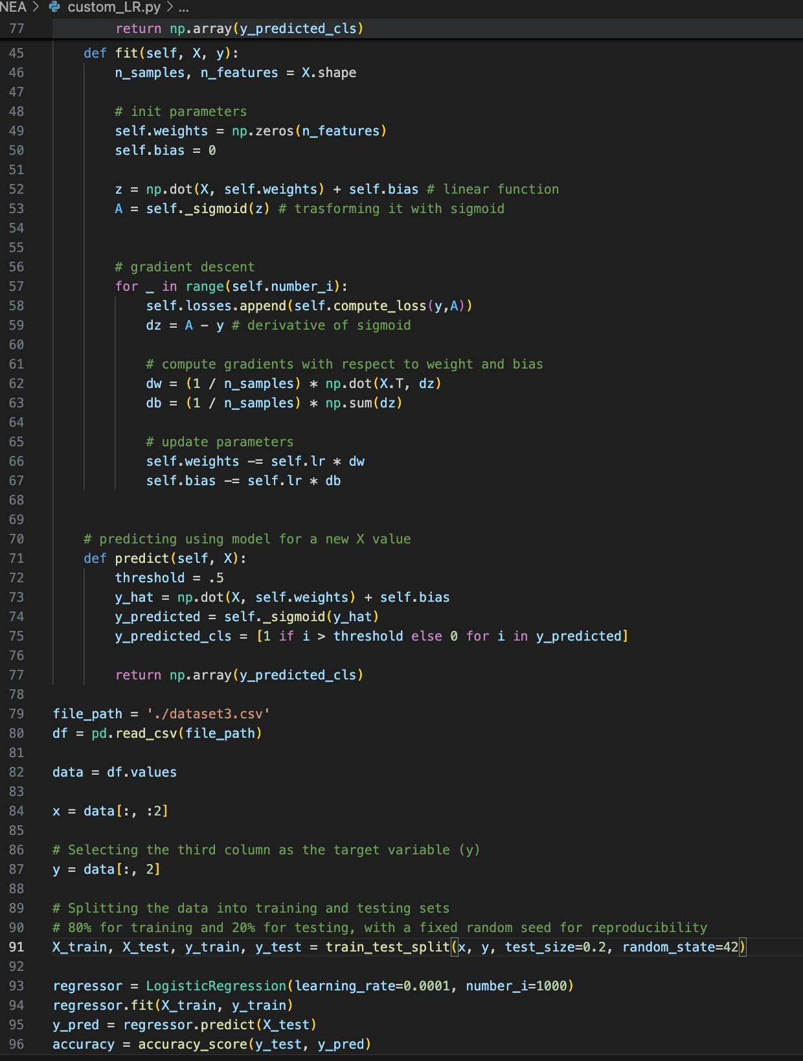
Code 32: logistic regression 2

The logistic_model.pkl is my logistic model used for predicting if my mean_log_ibi is of a normal person or not.

The following is the test and training data:

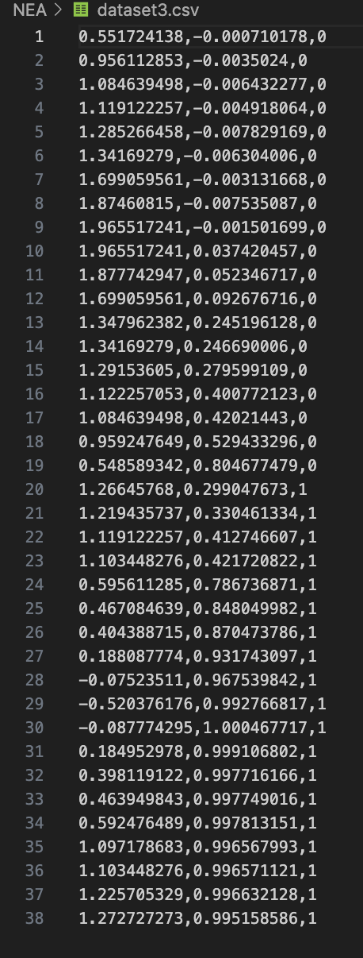
Image 34: csv file training and test data

The first column is the IBI the second is the probability and the third column is the classification of whether it is normal (0) or not normal (1)

Testing

API testing
The following was tested before making the front end.

Test number | TYPE | API | Purpose | Actual result | PASS/FAIL
API-001 | GET | http://127.0.0.1:5000/users?email=tanisha@gmail.com | Getting users name from users database based on the email the user typed | See in excel sheet | PASS
API-002 | POST | http://127.0.0.1:5000/create_contact | Adding new user to the database | See in excel sheet | PASS
API-003 | POST | http://127.0.0.1:5000/set_settings | Setting the settings for a user, if not already there creates new, if there updates. | See in excel sheet | PASS
API-004 | GET | http://127.0.0.1:5000/users_settings?email=tanisha@gmail.com | Get setting of a user | See in excel sheet | PASS
API-005 | GET | http://127.0.0.1:5000/ get_predictions?  email=tanisha@gmail.com | Returns true or false to start the break timer | See in excel sheet | PASS
API-006 | GET | http://127.0.0.1:5000/get_stats?email=tanisha@gmail.com | Returns mean log Ibi and entry number from database specific to the user. | See in excel sheet | PASS
Table 12: Api testing

Image 35: excel result table

Testing whole system
PASS
FAIL and NOT FIX
FAIL and FIXED

Test number | Test | Description | Expected | Actual | Pass/Fail
001 | Video Processing Accuracy Test | Use a sample video with a known number of blinks and check if the algorithm correctly counts the blinks. | The number of blinks calculated by the algorithm matches the known number. | The algorithm sometimes doesn’t pick up fast blinks or partial blinks | fail
002 | Logistic Regression Model Accuracy Test | Pass pre-labelled data (normal and dry eye blink rates) into the model and verify the output. | The model correctly classifies normal and dry eye blink rates or have a above 70% accuracy. | The algorithm has an 70% accuracy. So sometimes it determines the wrong probability. | fail
003 | Database Insertion Test | Check if the calculated output (0 or 1) from the logistic regression model is successfully stored in the database. | The database contains the expected value (0 or 1) for the current test. | Correctly inserts for the correct user.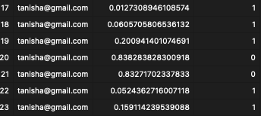 | pass
004 | Frontend Timer UI Test | Check if the frontend displays the timer correctly during the 20-second countdown. | Timer should automatically close after the 10 sec are done | Does close automatically after 10 sec  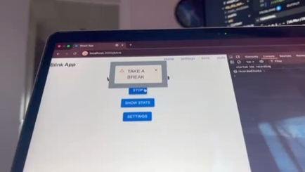 | pass
005 | Change in settings | Check if the timer duration changes when settings are changed | Changing 20 sec timer to 10 sec. should automatically close in 10 sec. | Results in a logical error. Wrong unit of time used, used seconds instead of minutes for the blink and Ibi timer. Break timer works.  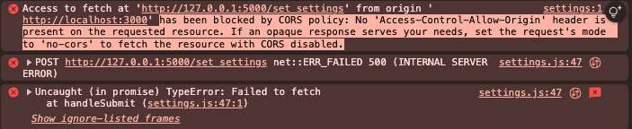  An error also occurs if you don’t change all the values, if you only change one and leave the rest by itself it will result in an error.  If you specify a number for all everything works. | fail
006 | Empty Video Upload Test | Try to upload an empty video file. | Display an error message about the invalid file. | Doesn’t give any error if it has 0 recorded chucks. | fail
007 | Edge Case with No Blinks Detected | Upload a video of a static object. | Blink count should be zero, and no error should occur. | Correctly returns 0 blinks | pass
008 | Statistics Data Consistency Test | Check whether the statistics displayed on the frontend match the values stored in the database. | The frontend should show accurate and consistent statistics based on the most recent database entries. | 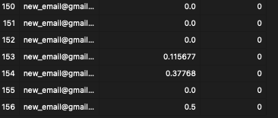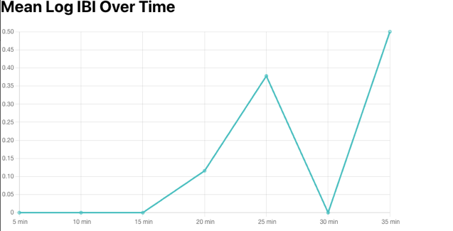 | pass
009 | Statistics Update Frequency Test | Continuously upload new videos and monitor how often the statistics update on the frontend. | Statistics should update as soon as new data is processed without significant lag. | Does show update immediately after it was added to the database | pass
010 | Settings display | Show the current settings of the user | Timer: chosen settings  Blink timer: chosen settings  Ibi timer chosen settings | 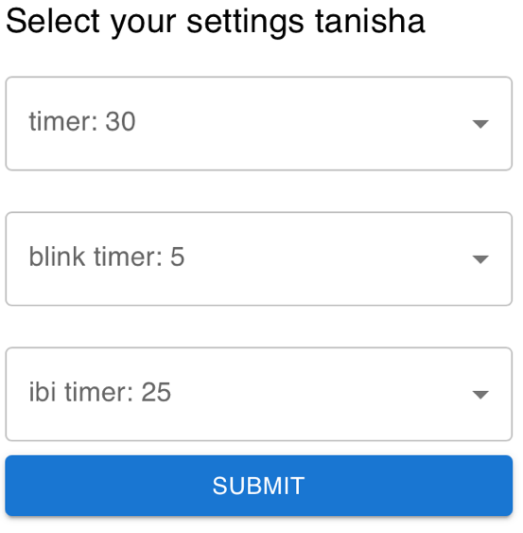 | pass
011 | Video recording | Video should be recorded correctly and sent to backend with no corruption | Nonempty video file sent to backend with no corruption | Sometimes the video recording feature in react doesn’t record properly leading to an empty video file. However, if you press stop and start again it start recording properly. This is because the mimetype I specified was webm but used mp4 which made a bug. | fail
Table 13: system testing

Fixes to fails
Test number | fix | Result/updated code
002 | Increased accuracy by changing the learning rate to get about 87% accurate. Still sometimes gives wrong predictions but less often.
005 | Fixed the datatype and turned seconds to minutes | 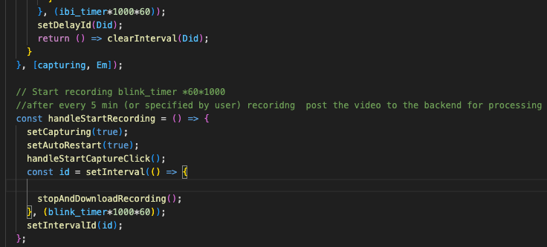
011 | Made sure everywhere I used mp4 | 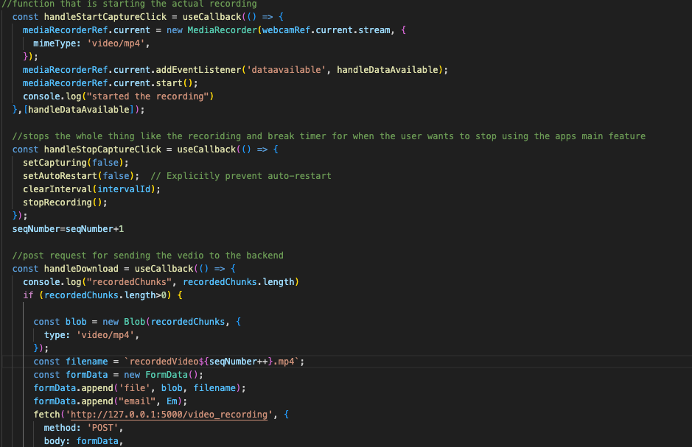
006 | Added an if condition and error message | 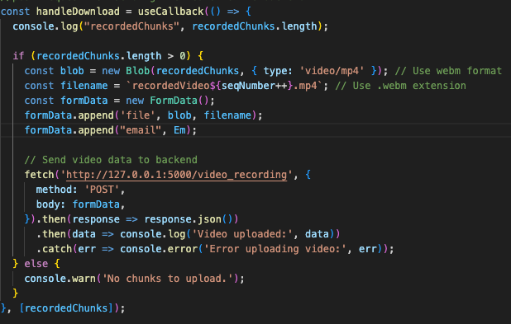
Table 14: fixes to fails

Reason why can’t fix the others
Test number | Test description | Why can’t fix
001 | Use a sample video with a known number of blinks and check if the algorithm correctly counts the blinks. Test should result in the correct number of blinks | One reason may be the resolution of the camera. This effects the distance calculation of the eyes. Cannot change camera.
005 | Changing 20 sec timer to 10 sec. should automatically close in 10 sec | After updating a single setting, the system attempts to retrieve additional data from the same website for the rest of the settings. However, the current configuration doesn't permit this action, leading to an error. I tried adjusting the configuration to allow fetching this data from the same source, but the issue still happened.
Table 15: reasons of not fixed

Instructions to run the program
Instructions on running the code is detailed bellow:

- Open 2 Vscode terminal (zsh).
- Cd into backend python
- Run the command “conda activate dlib_env”
- Run the command “python3 main.py”
- In the other terminal cd into my_dry_eye_app
- Run the command “conda activate dlib_env”
- Run the command “npm start”

Evaluation
- Users log in and sign in
RESULT: completed it however did not add password.
IMRPROVMENTS: Add password for better security.
- Decide blink rate is normal:
Software will monitor user’s eye blink rate as defined in the design document.
        - Software must be able to store IBI of blink
RESULT: I have successfully done this, being stored in temporarily in hash table, long term in database
LIMITATIONS: The IBI being stored will not be always accurate as partial blinks are also counted as blinks which is inaccurate.
IMPROVMENTS: use more advanced computer vision techinques.
        - Software must store average IBI over the 20 min in a database
RESULT: I have successfully done this.
        - Software must be able to predict if average IBI is normal or not
RESULT: I have done this however it is not always accurate
LIMITATIONS: As the data used to train my logistic regression model is not a lot the model is not perfectly accurate, and as the data used have been transformed multiple times, the data used in training itself is not as accurate. This makes the prediction not 100% accurate.
IMPROVMENTS: optimise logistic regression model for more accuracy in determining if IBI is normal or not by using more data and more accurate data.
        - Result must be able to store in a database
RESULT: I have successfully done this
- Notification of a timer shown to user if blink rate is not normal
        - 25 sec timer notification will automatically be started
RESULT: I have done this however the alert does not pop up over all the apps and webapps it only shows in the Blink app.
LIMITATIONS: if a user is on another tab or application, they won’t be able to see the break timer.
IMPORVMENTS: the alert system not determined in front end but by the user’s computer. Separate program to determine breaks, not decided in front end.
        - Alert sent to user that timer is finished
RESULT: Not complete, user doesn’t get alert timer has finished, but the timer reminder no longer shows once timer has finished.
IMPROVMENTS: alert the user that the timer has finished.
- User settings
        - Change break timer
RESULT: Completed
        - Change interval at which blink rate is compared (Blink timer) and Ibi timer rate at which videos are sent to backend
RESULT: completed
IMPROVMENTS: add validation to make sure that IBI timer is always bigger than Blink timer.
- History of blink rate
  - Graph to show blink rate for the day
RESULT: I have done this, but it displays all the user’s data not only for the day.
LIMITATION: as more data is added viewing the statistics on the graph will become hard to read and understand, as the user cannot specify how back they want the data to be displayed from.
IMPROVEMNTS: allow user to decide how back they want their data to be shown.

References
Al-Mohtaseb, Z., n.d. The Relationship Between Dry Eye Disease and Digital Screen Use. [Online]
Available at: https://pmc.ncbi.nlm.nih.gov/articles/PMC8439964/
Cleveland Clinic, n.d. Computer Vision Syndrome. [Online]
Available at: https://my.clevelandclinic.org/health/diseases/24802-computer-vision-syndrome
Flask, n.d. User’s Guide. [Online]
Available at: https://flask.palletsprojects.com/en/stable/
Geek for Geeks, n.d. Logistic Regression in Machine Learning. [Online]
Available at: https://www.geeksforgeeks.org/understanding-logistic-regression/
Geeks for Geeks, n.d. Eye blink detection with OpenCV, Python, and dlib. [Online]
Available at: https://www.geeksforgeeks.org/eye-blink-detection-with-opencv-python-and-dlib/
Geeks for geeks, n.d. Logistic Regression in Machine Learning. [Online]
Available at: https://www.geeksforgeeks.org/understanding-logistic-regression/
Geeks for Geeks, n.d. Multiprocessing in Python | Set 1 (Introduction). [Online]
Available at: https://www.geeksforgeeks.org/multiprocessing-python-set-1/
Geeks, G. f., n.d. Difference between Multiprocessing and Multithreading. [Online]
Available at: https://www.geeksforgeeks.org/difference-between-multiprocessing-and-multithreading/
Golden, M. I., Meyer, J. J., Zeppieri, M. & Pate, B. C., n.d. Dry Eye Syndrome. [Online]
Available at: https://www.ncbi.nlm.nih.gov/books/NBK470411/
Johnston, P. R., n.d. The interblink interval in normal and dry eye subjects. [Online]
Available at: https://pmc.ncbi.nlm.nih.gov/articles/PMC3565584/
Messmer, E. M., n.d. The Pathophysiology, Diagnosis, and Treatment of Dry Eye Disease. [Online]
Available at: https://pmc.ncbi.nlm.nih.gov/articles/PMC4335585/
Mondal, H., n.d. A Review on Dry Eye Disease Treatment: Recent Progress, Diagnostics, and Future Perspectives. [Online]
Available at: https://pmc.ncbi.nlm.nih.gov/articles/PMC10051136/
Ng, A., n.d. Machine Learning Specialization. [Online]
Available at: https://www.coursera.org/specializations/machine-learning-introduction?utm_medium=sem&utm_source=gg&utm_campaign=b2c_emea_multi_stanford_ftcof_multi_cx_dr_bau_gg_pmax_pr_gb_en_m_hyb_25-04_x&campaignid=22473258384&adgroupid=&device=c&keyword=&matchtype=&ne
React, n.d. Getting Started. [Online]
Available at: https://legacy.reactjs.org/docs/getting-started.html
React, n.d. Learn React. [Online]
Available at: https://react.dev/learn
React, n.d. Tutorial: Intro to React. [Online]
Available at: https://legacy.reactjs.org/tutorial/tutorial.html
scikit learn, n.d. LogisticRegression. [Online]
Available at: https://scikit-learn.org/stable/modules/generated/sklearn.linear_model.LogisticRegression.html
Shah, S., n.d. Prevalence and associated factors of dry eye: Our experience in patients above 40 years of age at a Tertiary Care Center. [Online]
Available at: https://pmc.ncbi.nlm.nih.gov/articles/PMC4738658/
Sourav Datta 1, S. S. B. B. P. N. S., n.d. The 20/20/20 rule: Practicing pattern and associations with asthenopic symptoms. [Online]
Available at: https://pmc.ncbi.nlm.nih.gov/articles/PMC10391416/
Talens-Estarelles, C., n.d. The effects of breaks on digital eye strain, dry eye and binocular vision: Testing the 20-20-20 rule. [Online]
Available at: https://pubmed.ncbi.nlm.nih.gov/35963776/
Tim, T. w., n.d. Python Website Full Tutorial - Flask, Authentication, Databases & More. [Online]
Available at: https://www.youtube.com/watch?v=dam0GPOAvVI
W3schools, n.d. https://react.dev/learn. [Online]
Available at: https://www.w3schools.com/REACT/DEFAULT.ASP

Abbreviations

Sl No | Acronym | Description
1 | IBI | Inter blinking interval
2 | EAR | Eye aspect ratio
Table 16: abbreviations

